2015
Enterprise
green
Communities

Single family
scopes of work

About Us

Enterprise Green Communities
Enterprise Green Communities is the first national green building program focused entirely on affordable housing. Launched by Enterprise in fall 2004, Green Communities is designed to help developers, investors, builders and policymakers make the transition to a greener future for affordable housing. Visit www.enterprisecommunity.org/green.

About Enterprise
Enterprise is a leading provider of the development capital and expertise it takes to create decent, affordable homes and rebuild communities. Enterprise has introduced neighborhood solutions through public–private partnerships with financial institutions, governments, community organizations and others that share our vision. Enterprise has raised and invested more than $18.6 billion in equity, grants and loans to help build or preserve more than 340,000 affordable rental and for-sale homes to create vital communities. Enterprise is currently investing in communities at a rate of $1 billion a year. Visit http://www.enterprisecommunity.com/solutions-and-innovation/enterprise-green-communities to learn more about Enterprise’s efforts to build communities and opportunity.

Acknowledgments
Enterprise Green Communities thanks the following individuals and organizations for their insights and assistance producing the suite of specifications tools supporting the 2015 Enterprise Green Communities Criteria:
Alistair Jackson

O’Brien & Company
Andrea Lewis

O’Brien & Company
Elly Bunzendahl

O’Brien & Company
Maureen Mahle

Steven Winter Associates, Inc.

Copyright © 2015 Enterprise Community Partners, Inc. All rights reserved.

Contractor Introduction

read this before Editing and sending scopes of works to TRADEs

This project is pursuing Enterprise Green Communities Certification. In addition to numerous mandatory requirements, the project must also earn a minimum number of optional points for certification. The quality of work completed by individual trades is critical to the success of this project, and the rigor of inspections and performance verification may be more than your sub-contractors are used to.

The details in the following Scopes of Work Templates are designed to clarify the expectations related to product specifications and submittals, installation requirements and quality control inspections. Providing these to your subcontractors when you put work out to bid will allow them to:
- understand the expectations for this job;
- bid accordingly; and
- prepare for quality work that is verified and tested on site.

These requirements should be communicated as contractual obligations for trades bidding on and selected to engage in the project. They represent industry best practices, and should not significantly increase bid prices.

how are the scopes of work organized?

These editable Scopes of Work Templates are organized by various trades or trade groupings, and include a general introduction that explains the project’s pursuit of Enterprise Green Communities Certification and the trade’s role and accountability in achieving certification. Each template includes a table that notes relevant Submittal, Product, and Execution requirements similar to what you would find in project specifications, but in a component-by-component basis.

Your Role in Encouraging cross-trade coordination and Communication
Experience shows that successful end results take a coordinated effort between the construction trades. When trades acknowledge how their work impacts the work of other trades, errors and failures are reduced or eliminated, project schedules and budgets are met, and quality and performance improves (often meaning fewer call backs and good referrals for the GC).
Use Table 1 (below) to help you manage this coordination and customize the Scopes of Work for your sub-contractors. For each typical trade, the Table calls out job requirement resources and keys for success in meeting green building goals.
Preconstruction Communication Meeting: We highly recommend that General Contractors require the sub-contractor leads for each trade to attend a pre-construction coordination meeting, in which you can:
- clarify quality expectations;
- reinforce accountability for implementing certification requirements in sub-contractor scopes;
- address common and project specific challenges that trades will need to coordinate on, such as maintaining continuous air and thermal barriers; and
- draw attention to the fact many measures will be tested and field-verified.
Use this meeting to establish the need for cross-trade communication and collaboration, and assign one of your team to be responsible for this from the project outset.

meeting energy performance requirements
You will need to customize the Scopes of Work to address the energy performance requirements associated with New Construction and Substantial and Moderate Rehab projects.
New Construction projects are required to achieve ENERGY STAR Homes Certification, pursuant to Criterion 5.1a Mandatory Building Performance Standard for New Construction for single-family detached, or attached homes, (but also applicable to multifamily buildings with 4 units or fewer or three stories or fewer, or buildings up to five stories where each dwelling unit has its own heating, cooling, and hot water).
The ENERGY STAR Homes Certification requirements impact both the design and construction team scopes – clearly called out in a set of Checklists to aid with third-party verification of compliance. This suite of checklists for ENERGY STAR Certified Homes, Version 3/3.1 (Rev. 08), are provided in as an attachment here. They have been annotated to identify the typical party responsible for achieving certification requirements. ENERGY STAR documents are updated quarterly – projects are typically required to use the version that is current at the time building permits are pulled. It is your responsibility to use, and share with your team, the most current version for your project. We suggest checking for updates at http://www.energystar.gov/index.cfm?c=bldrs_lenders_raters.nh_v3_guidelines.
As the General Contractor, you have a unique role in bridging the work of the design team with that of the various trades engaged in your project. In particular, some of the ENERGY STAR requirements may fall to different trades, depending on the nature of the project, and it is your responsibility to assign those requirements to the most appropriate trade as part of their scope.
Moderate or Substantial Rehab projects are required to complete an energy rating, using the RESNet Home Energy Rating System (HERS), earning a HERS Index of 85 or less, in accordance with Criterion 5.1c. The HERS rating also requires field verification of both existing building conditions and new work, similar to ENERGY STAR. While not mandatory, project teams MAY apply the ENERGY STAR checklists to the new construction components of rehab projects where applicable - is certainly a best practice approach.
NOTE: To be eligible to install HVAC equipment in homes being certified under ENERGY STAR Version 3, HVAC contractors must be credentialed through and EPA-recognized HVAC Quality Installation and Training Organization (H-QUITO). HVAC contractors must submit documentation of their credential with their bids. For more information on how to find credentialed HVAC contractors, visit: https://www.energystar.gov/index.cfm?c=bldrs_lenders_raters.nh_hvac_contractors

How to customize the scopes of work
The templates include the following customization tips:
- General recommendations or considerations are noted in ‘Comment Bubbles.’ To remove individual comment boxes, click in the comment box, right click and select ‘delete.’ To remove all comment boxes, Go to the Review tab > Comments group. Click the drop-down arrow to the right of Delete. Select Delete All Comments in Document.
- Italics font indicates optional criterion. Enterprise recommends deleting or striking out on a hard copy any criterion not pursued by a project so sub-contractors only look at requirements associated with the project.
- Orange font indicates a choice. Select the appropriate spec, and delete or strike out the others.
- Prompts for selecting the correct energy performance criterion for New Construction and Moderate or Substantial Rehab Projects. For New Construction projects, you will need to assign responsibility for those ENERGY STAR Homes Certification requirements not attributed to a specific trade. For Rehab projects, unless the project documents require compliance with ENERGY STAR standards where applicable, you should delete any attached ENERGY STAR reference documents.

other tools and resources
Additionally, Single Family General Contractors that develop project specifications may want to refer to or use the following tools that are based on the MasterSpec organization:
- The Companion Single Family Spec / Criterion Matrix is an editable Excel file that identifies how each Green Communities Criteria maps to each MasterSpec Division. Specifically, the matrix indicates whether a Submittal (P), Product (P), or Execution (E) responsibility is associated with each criterion. This matrix can serve as a planning tool for customizing the template specifications or as a standalone resource for project teams.
- The Single Family Specifications Template is an editable document that identifies specific sections that relate to mandatory and optional Enterprise Green Communities criterion, and also incorporates recommendations and tips to include.
- The 2015 Enterprise Green Communities Criteria also has relevant resources for mandatory and optional criterion that may be useful for General Contractors and individual trades.

Table 1. Overview of Trade-Specific Scope of Work Resources and Customization Recommendations
The table below provides an overview of available Enterprise resources for various trades, as well as keys for success meeting Enterprise Green Communities Criteria.
Trade | Resources | Keys for Success
Concrete  All manner of concrete work, including Portland cement and asphalt, including construction of foundations, driveways or pathways, and finishes | Scope of Work Template  New Construction Only: Annotated ENERGY STAR Homes Water Management System Builder Requirements | Coordination with landscape/stormwater management to keep heavy vehicles and concrete washout clear of infiltration zones. Communicate modified curing schedules when using high percentages of flyash or slag.
Framing, Insulation/Air-Sealing and Drywall  Structural and non-structural framing, exterior and interior sheathing, installation of exterior rigid and interior cavity insulation, blocking and sealing of all penetrations through air barrier, installation of all interior drywall, including any pre-rocking and final drywall hanging, taping and finishing | Scope of Work Template  New Construction Only: Annotated ENERGY STAR Homes Rater Field Checklist | Clear understanding of the air barrier alignment is critical to framing details that facilitate air barrier continuity and fast, effective air-sealing. All parties should review the Thermal Enclosure Checklist requirements.  Design framing layouts to allow good access and facilitate high quality insulation in all cavities, or sequence accordingly.  Coordination of insulation and sheathing for areas that should be insulated and pre-rocked to facilitate efficient sequencing – such as behind tubs, showers, walls behind/beneath stairs, and attic kneewalls, for example.  Clear understanding of where the interior drywall contributes to the building air-barrier and where equipment and fixtures that penetrate that drywall must be effectively sealed to it.
Roofing / Siding / Weather Resistive Barrier  Installation of weather resistive barrier (WRB), and water shedding layer (roofing, siding, etc.), and all associated trim and flashing | Scope of Work Template  New Construction Only: Annotated ENERGY STAR Homes Water Management System Builder Requirements  Annotated ENERGY STAR Homes Rater Field Checklist | Correct installation of these components to ensure a durable effective water proof building requires effective integration and sequencing of measures.  Where the weather resistive barrier is also being used as the air barrier, it is critical that installers ensure good continuity between WRB and other air-barrier components at all key transitions, and that roofing and siding installers do not compromise the continuity of WRB/air-barrier in the course of their work.
Heating, Ventilation and Air Conditioning (HVAC)  Trades providing heating and cooling, including mechanical and ventilation services | Scope of Work Template  Annotated ENERGY STAR Homes HVAC Design Report  Annotated ENERGY STAR Homes HVAC Commissioning Checklist | Coordination across HVAC and electrical trades is critical for success, particularly with regard to installation of fans, duct work and terminations.  Provide the completed “HVAC Design Report” to HVAC trades prior to bidding so that they see the full design intent and requirements related to equipment, sizing, and installation. Trades are not responsible for this form, but their work directly impacts project certification, so these forms are provided for their information. If your project is design-build, include the blank form with a note that all fields must be completed by the appropriate trade prior to design approval.  The HVAC Commissioning Checklist is included for HVAC trades so they can appropriately plan and bid for verified and tested quality workmanship.
Electrical  When responsible for installation of exhaust fans, lighting and electrical wiring | Scope of Work Template  Annotated ENERGY STAR Homes HVAC Design Report  Annotated ENERGY STAR Homes Rater Field Checklist | Coordination across HVAC and Electrical trades is critical for success, particularly with regard to installation of fans, duct work and terminations, as well as lighting and electrical wiring that penetrates exterior and/or interior air barriers.  Please provide the completed “HVAC Design Report” to Electrical trades prior to bidding so that they see the full design intent and requirements related to ventilation and exhaust equipment, sizing, and installation if it falls within their scope. Trades are not responsible for this form, but their work directly impacts project certification, so these forms are provided for their information. If your project is design-build, include the blank form with a note that all fields must be completed by the appropriate trade prior to design approval.  This document is recommended for Electrical contractors because the ventilation and exhaust fan scope often falls within their contract. If the Electrical trade will not have any scope related to procuring and installing fans or fan controls, you do not need to provide this document.  Electrical contractors are not responsible for the Rater Field Checklist, but it provides important guidance on ensuring air barrier continuity where exhaust fans, recessed cans and electrical outlets penetrate air-barrier materials, and where wiring runs may complicate cavity insulation installation.
Plumbing  Responsible for designing and/or installing plumbing, and procuring and installing indoor plumbing fixtures | Scope of Work Template  Annotated ENERGY STAR Homes Rater Field Checklist | Coordinate with Framing and HVAC contractors to minimize length and number of bends in pipe runs, particularly hot water distribution.  Do not penetrate ducts or plenums, make clean, tight penetrations through framing, sheathing, and decks and seal penetrations air-tight after installation in accordance with the Rater Field Checklist.  Confirm delivered fixtures (including aerators and flow restrictors) meet the performance requirement and, wherever possible, confirm installed performance.
Landscaping and Irrigation  Responsible for designing and/or installing stormwater management (e.g., raingardens and bioretention), and irrigation systems | Scope of Work Template | Ensure landscape areas to be used for rainwater infiltration are fully protected from heavy vehicles and from concrete washout throughout construction.  Ensure delivered irrigation fixtures and controls meet the performance requirements, properly commission them to ensure correct water delivery/distribution. Provide clear zone map and operations instructions to owner/occupant.

The following is a snapshot of the ENERGY STAR Certified Homes, Version 3/31/1 (Rev 08) documents, annotated to identify the trades are responsible for executing the various requirements. Those requirements where responsibility often varies from one project to the next are attributed to the General Contractor, as a cue to assign this scope to the most appropriate trade on your project.
Where relevant, these annotated documents are attached to the Trade Scopes of Work templates, calling out only those responsibilities typically falling under their scope.
Be sure to obtain the original checklists and full footnotes from the ENERGY STAR website: http://www.energystar.gov/index.cfm?c=bldrs_lenders_raters.nh_v3_guidelines

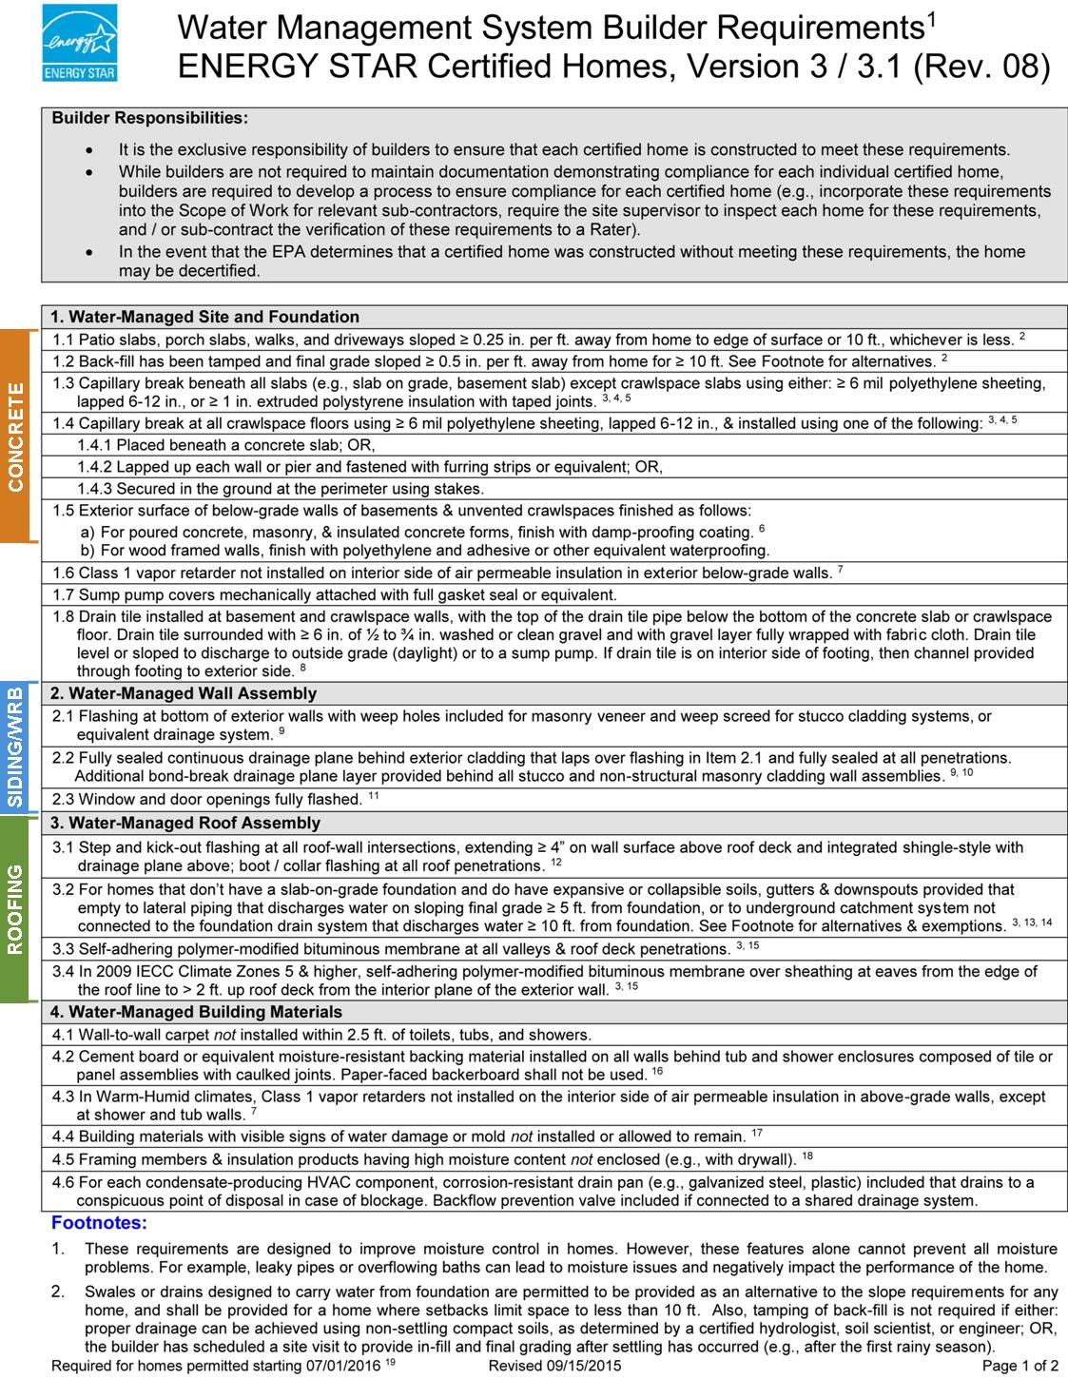

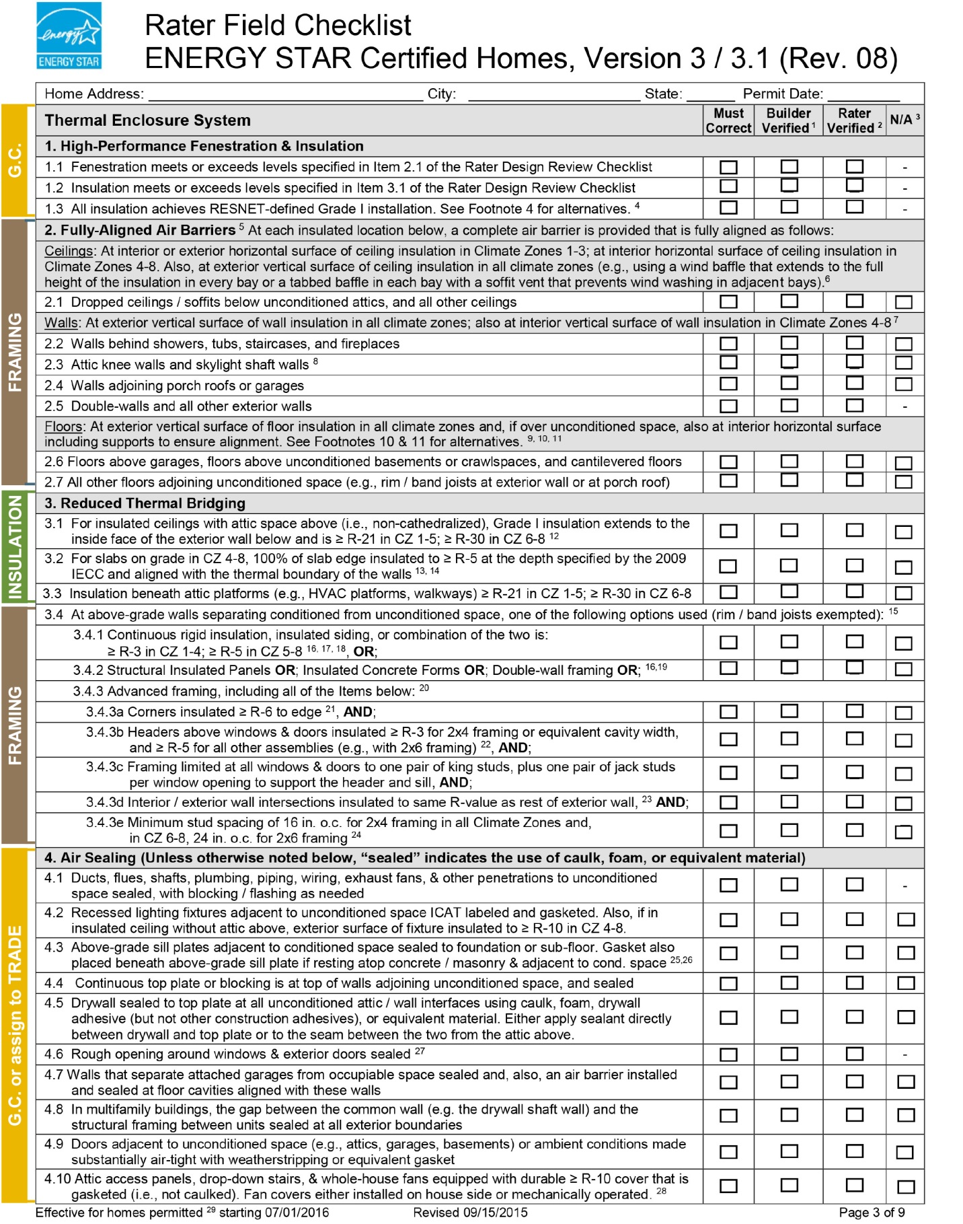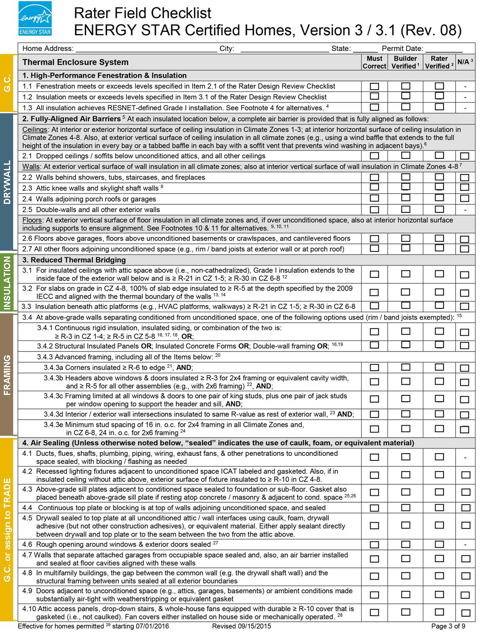

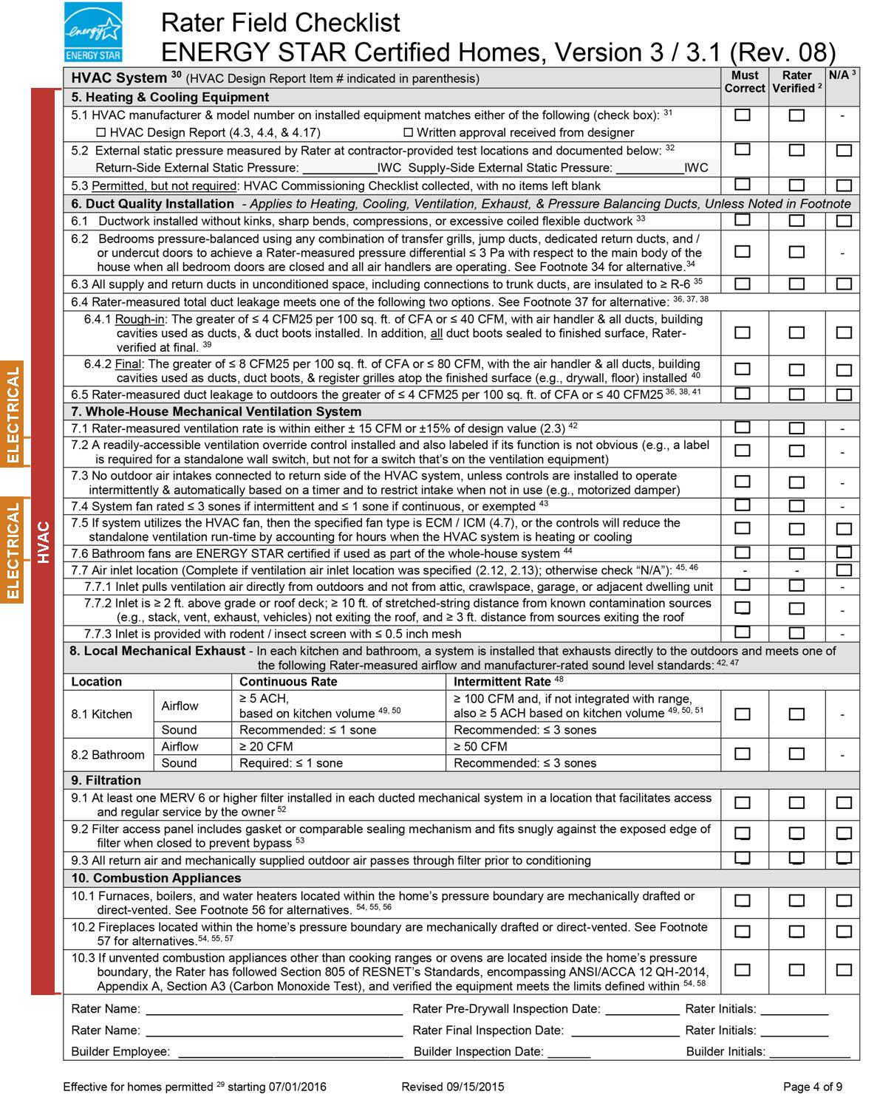

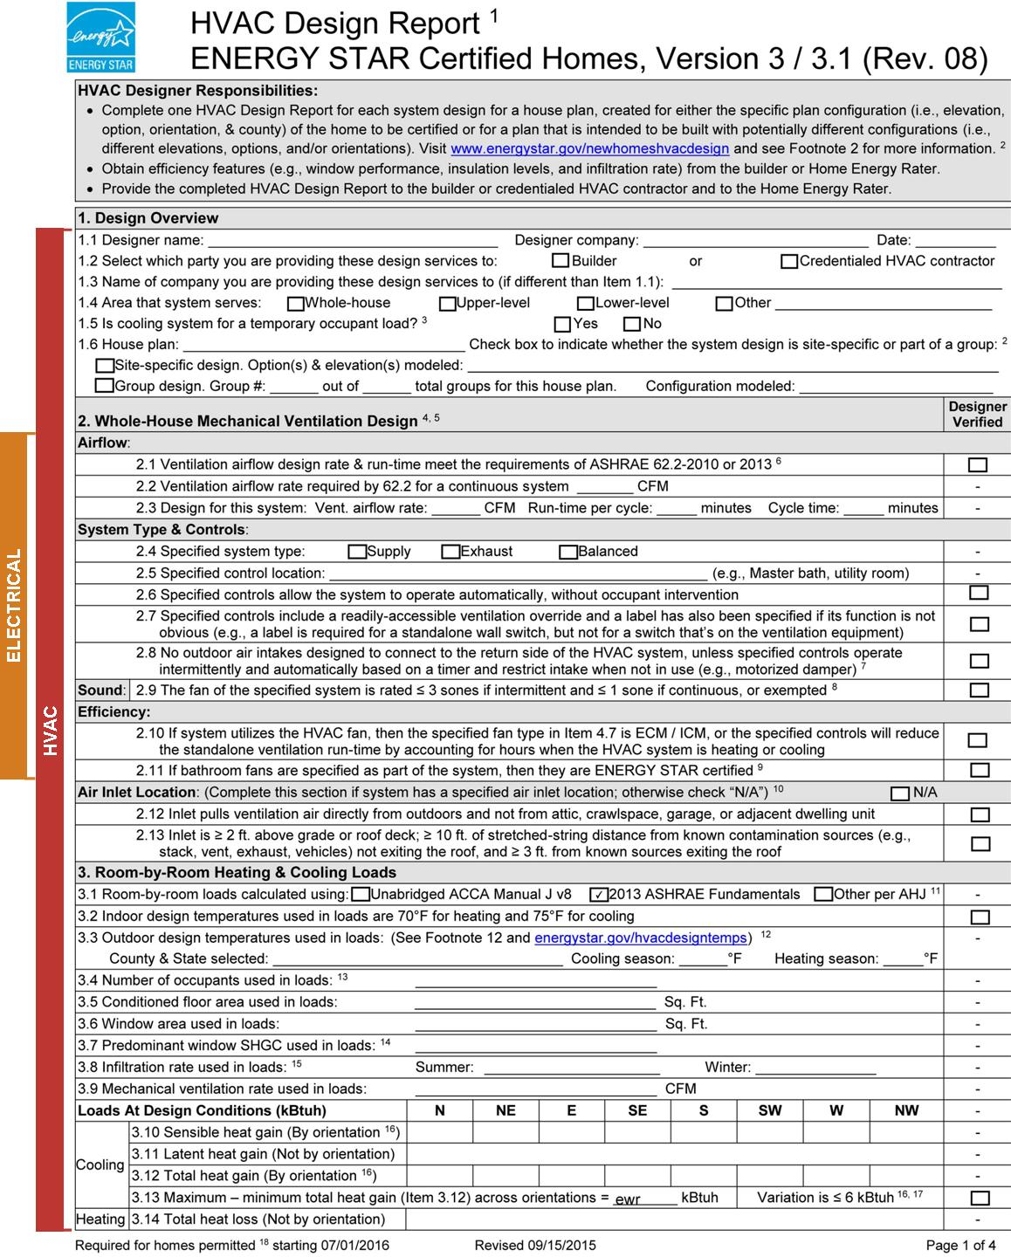

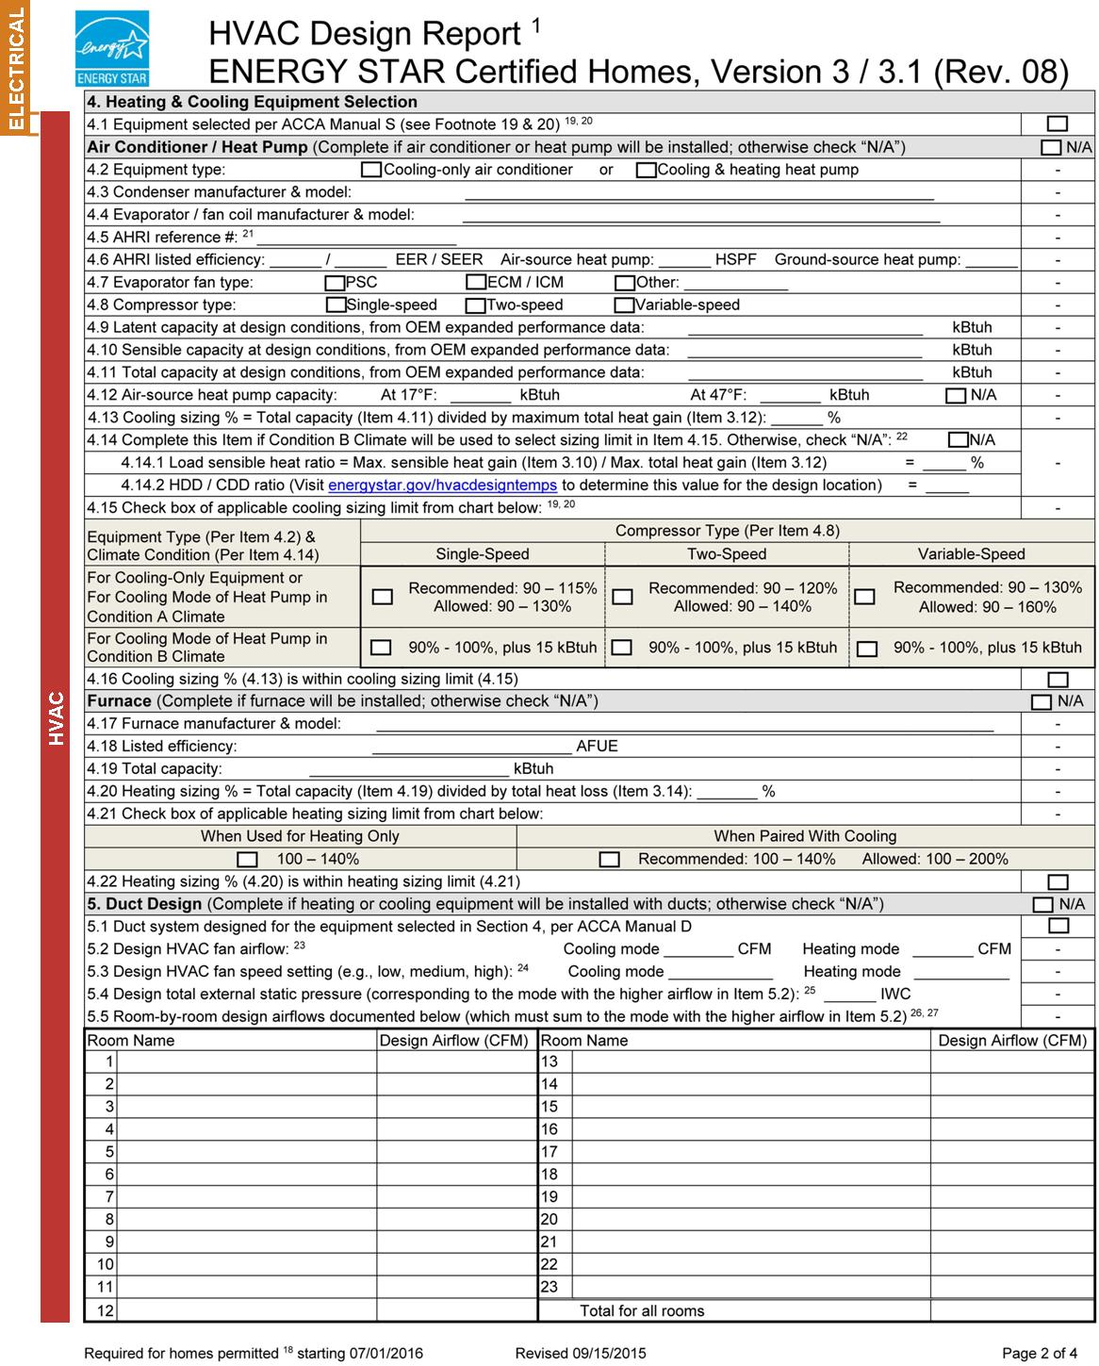

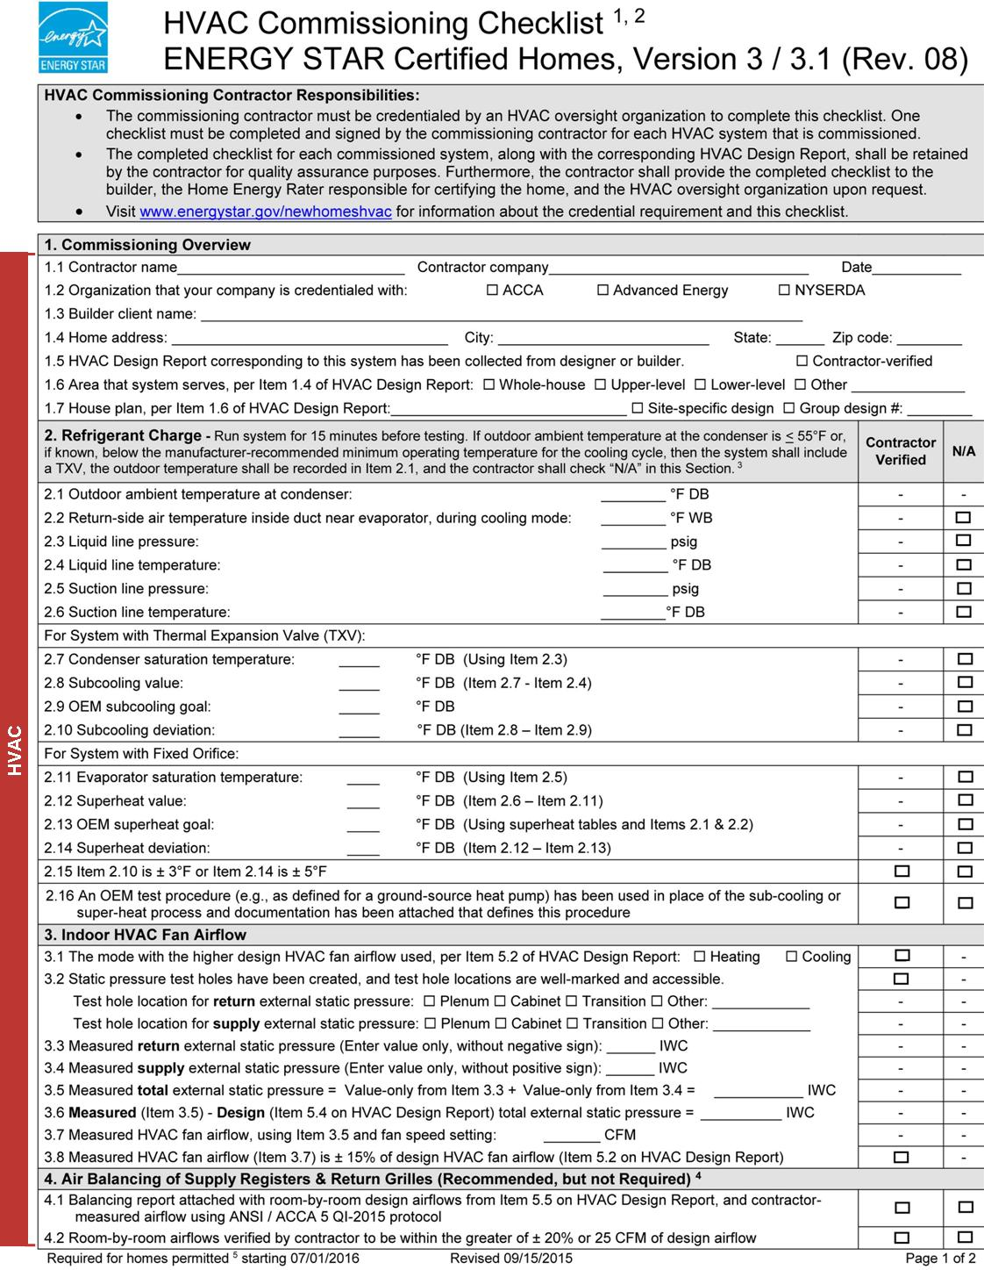

Concrete

read this before bidding
You are bidding on a project that is pursuing Enterprise Green Communities Certification. This certification is awarded to projects that follow design and installation parameters that use fewer natural resources, generate less waste and contain fewer toxic materials, reduces the cost of operation and maintenance, leading to a healthier environment. In addition to numerous mandatory requirements, the project must also earn a minimum number of optional points for certification.
Your quality of work is critical to the success of this job. This Scope of Work outlines contractual requirements that directly support the selected certification requirements (Enterprise criterion) that your trade will be held accountable for if selected. Please read through this document carefully to know what is expected of your trade with regard to products, submittals, execution, quality control and coordination with other trades. How does your work relate to Enterprise Green Communities?

coordination, communication and quality assurance Across Trades
Experience shows that successful end results take a coordinated effort across trades and with the General Contractor, and that when trades acknowledge how their work intersects, influences and can impact the work of trades outside of their own scope, projects pass more inspections the first time, errors and failures are reduced or eliminated, and project schedules and budgets are met.
Examples of best communication and cross-trade coordination practices include:

Participation at a preconstruction coordination meeting;

Trade foremen that build and maintain crew awareness of trade sequencing on a specific project;

Processes for tracking and communicating to the General Contractor or other trades issues that need timely attention from other trades to ensure quality and reduce rework expenses later in the project.

Submittals, Products, and Execution
You are required to provide the General Contractor with product data in accordance with contract requirements. Careful attention must be paid to product requirements related to your trade, as these have been specified to meet specific certification requirements. Table 1 shows the submittal, product, and execution requirements specific to the Enterprise Green Communities Criteria. Your work will be verified on site by a third-party verifier. You will be contracted to provide quality of work in line with widely-recognized best practices; necessary to earn certification. This may vary from “typical” construction practices.

Read through the Attachments
Enterprise Green Communities Criteria requires ENERGY STAR Homes Certification of new construction single-family projects. This involves the design, documentation, installation, and verification of items in compliance with the ENERGY STAR Certified Homes requirements in force at the time building permits are pulled. The most current ENERGY STAR Homes Water Management System checklist Version 3 is attached and annotated to reflect requirements related to concrete installation, for your convenience.

Table 2. Enterprise Green Communities Criteria and associated submittal, product, and execution requirements related to Concrete
Material and Associated Enterprise Green Communities Criteria | Submittal Requirements | Product Requirements | Execution Requirements
3.2 Erosion & Sedimentation Control |  |  | Follow all Best Management Practices (BMPs) within the Total Erosion and Sedimentation Control (TESC) Plan.
Exterior concrete Paving  3.7 Reducing Heat Island Effect: Paving | Documentation of solar reflectance of 0.3 for exterior concrete paving | At least 50% of site hardscape has solar reflectance of 0.3, or uses open grid pavers that are 50% vegetated
Interior concrete coatings or sealants  6.1 Low/No VOC Paints, Coatings, and Primers  6.2 Low/No VOC Adhesives and Sealants | VOC level in g/L | For all interior paints, coatings, primers, adhesives, and sealants, use only products with VOC levels that comply with the respective VOC limits shown in 018113 Part 2 Products. D. Materials under Criteria 6.1 and 6.2
Concrete  6.4 Regional Materials | Product information that confirms exact location where the [cement] and/or [aggregate] were extracted, processed, and manufactured. | Use products that were extracted, processed, and manufactured within 500 miles of the project for a minimum of 50%, based on cost, of the respective building material’s value
concrete  6.12 Construction Waste Management | Submit all project-specific individual recycle and/or waste management tickets for concrete |  | Recycle all concrete
Beneath concrete slabs  7.5 Vapor retarder strategies | Product information for [clean aggregate used as capillary break] or [geotextile drainage material matting applied over sand base]  Product information for 6-mil polyethylene sheeting  Photos documenting capillary break installation | For capillary break, install either [4-inch layer of ½-inch diameter or greater clean aggregate] or [4-inch uniform layer of sand, overlain with a layer of strips of geotextile drainage matting]  Above capillary break, install at least 6-mil polyethylene sheeting overlapped at least 6 inches at the seams | If using geotextile drainage matting above sand layer, follow manufacturer’s instructions for installation and overlapping of material.
BENEATH CONCRETE SLABS  7.8 Radon Mitigation (in EPA Zone 1 areas) | Product information associated with radon-resistant features below the slab  Photos documenting passive radon-resistant features beneath the slab | Passive radon-resistant features beneath the slab should meet ANSI-AARST Standard: Reducing Radon in New Construction: 1 & 2 Family Dwellings and Townhouses, CCAH-2013 | Installation methods should meet ANSI-AARST Standard: Reducing Radon in New Construction: 1 & 2 Family Dwellings and Townhouses, CCAH-2013
Concrete  8.3 Resident Engagement Manual | Specific maintenance instructions for any interior or exterior exposed concrete, including frequency of maintenance inspections or tasks and approved maintenance or cleaning products to use with finished concrete

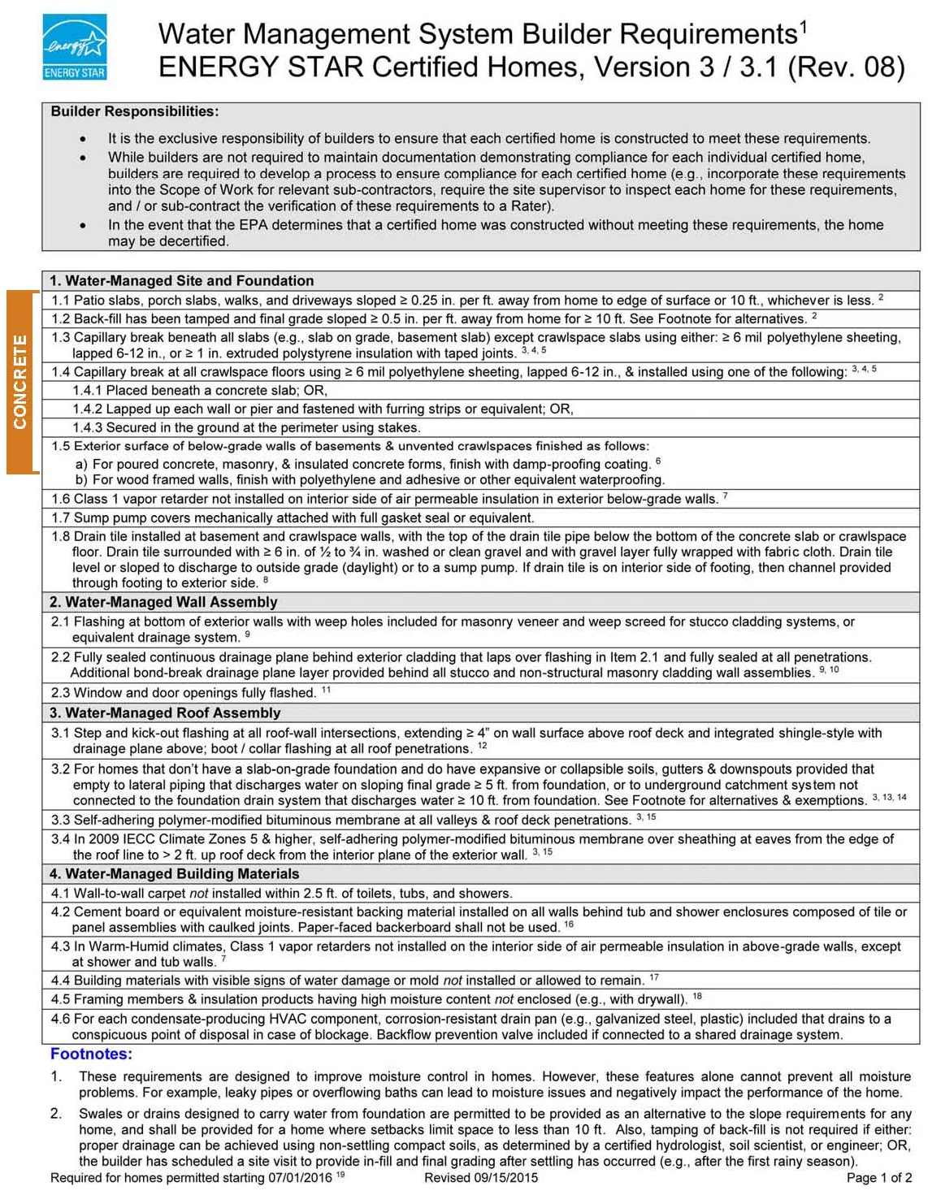

Framing, Insulation, Air Sealing, and Drywall

read this before bidding
You are bidding on a project that is pursuing Enterprise Green Communities Certification. This certification is awarded to projects that follow design and installation parameters that use fewer natural resources, generate less waste and contain fewer toxic materials, reduces the cost of operation and maintenance, leading to a healthier environment. In addition to numerous mandatory requirements, the project must also earn a minimum number of optional points for certification.
Your quality of work is critical to the success of this job. This Scope of Work outlines contractual requirements that directly support the selected certification requirements (Enterprise criterion) that your trades will be held accountable for if selected. Please read through this document carefully to know what is expected of your trade with regard to products, submittals, execution, quality control and coordination with other trades.

coordination, communication and quality assurance Across Trades
This Scope of Work addresses responsibilities that are often sequenced across multiple trades in order to achieve the Enterprise requirements. Experience shows that successful end results take a coordinated effort across trades and with the General Contractor, and that when trades acknowledge how their work intersects, influences and can impact the work of trades outside of their own scope, projects pass more inspections the first time, errors and failures are reduced or eliminated, and project schedules and budgets are met.
With specific regard to the issue of air sealing and maintaining thermal barriers, the trades grouped in this Scope of Work may need a higher degree of communication and attention to details that may impact the quality of their work or that of trades sequenced prior to or after their work. Examples of best practices include:

Participation at a preconstruction coordination meeting;

Trade foremen that build and maintain crew awareness of trade sequencing on a specific project;

Processes for tracking and communicating to the General Contractor or other trades issues that need timely attention from other trades to ensure quality and reduce rework expenses later in the project.

Submittals, Products, and Execution
You are required to provide the General Contractor with product data in accordance with contract requirements. Careful attention must be paid to product requirements related to your trade, as these have been specified to meet specific certification requirements. Table 1 shows the submittal, product, and execution requirements specific to the Enterprise Green Communities Criteria. Your work will be verified on site by a third-party verifier. You will be contracted to provide quality of work in line with widely-recognized best practices; necessary to earn certification. This may vary from “typical” construction practices.

Read through the Attachments
Enterprise Green Communities Criteria requires ENERGY STAR Homes Certification of new construction single-family projects. This involves the design, documentation, installation, and verification of items in compliance with the ENERGY STAR Certified Homes requirements in force at the time building permits are pulled. The most current ENERGY STAR Homes Water Management System checklist Version 3 is attached and annotated to reflect requirements related to concrete installation, for your convenience.

Table 3. Enterprise Green Communities Criteria and associated submittal, product, and execution requirements related to framing, insulation, air sealing, and drywall
Material and Associated Enterprise Green Communities Criteria | Submittal Requirements | Product Requirements | Execution Requirements
All  5.1a Building Performance Standard: New Construction |  |  | Per Mandatory requirements, your work will be verified by a 3rd-party ENERGY STAR Rater. Familiarize yourself with the related ENERGY STAR requirements that are annotated in the attached Rater Checklist and are additional to the details below
All  5.1c Building Performance Standard: Substantial and Moderate Rehab |  |  | Per Mandatory requirements, your work will be verified by a 3rd-party HERS Rater  For best practice, ensure work is consistent with design requirements; reference applicable ENERGY STAR requirements in the attached Rater Checklist where required
All Interior adhesives sealants  6.1 Low/No VOC Paints, Coatings, and Primers  6.2 Low/No VOC Adhesives and Sealants | VOC level in g/L | For all interior paints, coatings, primers, adhesives, and sealants, use only products with VOC levels that comply with the respective VOC limits shown in 018113 Part 2 Products. D. Materials under Criteria 6.1 and 6.2
Framing (wood, concrete, steel, and/or aluminum)  5.1a Building Performance Standard: New Construction  5.1c Building Performance Standard: Substantial and Moderate Rehab  6.3 Recycled Content Material | Product information that confirms post-consumer and post-industrial recycled content for [wood framing], [steel framing], [aluminum framing] | At least 25% post-consumer content or 50% post-industrial content; for [wood framing], [steel framing], [aluminum framing] | Per Mandatory requirements in 5.1a, above-grade exterior walls must use one of the following options (rim/band joists exempted): [continuous rigid insulation, insulated siding, or a combination of the two] or [structural insulated panels or insulated concrete forms or double-water framing] or [advanced framing, including all items listed in the ENERGY STAR Rater Checklist]  Per Mandatory requirements in 5.1c, your work will be verified by a 3rd-party HERS Rater  For best practice, ensure work is consistent with thermal envelope design requirements; reference applicable ENERGY STAR requirements in the attached Rater Checklist where required
INSULATION  6.3 Recycled Content Material | Product information that confirms post-consumer and post-industrial recycled content for [fiberglass batt], [cellulose], [rigid panel] | At least 25% post-consumer recycled content or 50% post-industrial for [fiberglass batt], [cellulose], [rigid panel] | Per Mandatory requirements in 5.1, all exterior wall insulation must be installed to meet Grade I standards (or Grade II if continuous exterior insulation is used), including at framing intersections, corners, headers, and rim joists. See ENERGY STAR Homes Insulation Critical Details Tech Tips for additional guidance.
WOOD FRAMING  6.4 Regional Materials | Product information that confirms exact location where the wood framing materials were extracted, processed, and manufactured. | Use wood framing products that were extracted, processed, and manufactured within 500 miles of the project for a minimum of 50%, based on cost, of the respective building material’s value | See ENERGY STAR Requirements for execution specifics related to framing. See ENERGY STAR Homes Framing Critical Details Tech Tips for additional guidance.
DRYWALL / INTERior sheathing  6.4 Regional Materials | Product information that confirms exact location where the drywall materials were extracted, processed, and manufactured. | Use products that were extracted, processed, and manufactured within 500 miles of the project for a minimum of 50%, based on cost, of the respective building material’s value | Per Mandatory requirements in 5.1, ensure any pre-rock that is installed is compliant and coordinate with the insulator to ensure all exterior and party walls are fully insulated and verified prior to pre-rock
Structural WOod FRAMING  6.5 Certified, Salvaged, and Engineered Wood Products | Product information that confirms the total cost or value and: [Chain of Custody Certificate for any products certified in accordance with the Forest Stewardship Council, proof that products were salvaged, and/or cut sheets for engineered wood demonstrating they do not include urea formaldehyde-based binders] | Use products that are [certified in accordance with the Forest Stewardship Council, salvaged, or engineered and do not include urea formaldehyde-based binders] for a minimum of 25% of all structural wood products, by cost or value | See ENERGY STAR Homes Framing Critical Details Tech Tips for additional guidance.
FRAMING  6.6 Composite Wood | Product documentation demonstrating plywood and OSB are compliant with California 93120 Phase 2 for materials within the building envelope | All composite wood products within the building envelope must be certified as compliant with California 93120 Phase 2 | If compliant products are not available, then all exposed edges of composite wood materials within the building envelope must be sealed with a sealant that meets the VOC limits shown in 018113. See ENERGY STAR Homes Framing Critical Details Tech Tips for additional guidance.
Drywall  6.9 Mold Prevention: Tub & Shower Enclosures | Product documentation demonstrating all drywall behind tub and shower enclosures meets ASTM #D3273 | Unless using a one-piece fiberglass tub/shower enclosure, use only moisture-resistant backing materials such as cement board, fiber cement board, or equivalent per ASTM #D3273 behind tub/shower enclosures | Ensure any pre-rock that is installed is compliant and coordinate with the insulator to ensure all exterior and party walls are fully insulated and verified prior to pre-rock
FRAMING: subfloor  6.10 Asthmagen-Free Materials | Product documentation demonstrating ULEF or NAF compliance | Use only ULEF (Ultra Low Emitting Formaldehyde) or NAF (No Added Formaldehyde) products for subflooring or other interior composite wood uses | See ENERGY STAR Homes Framing Critical Details Tech Tips for additional guidance.
INSulation  6.10 Asthmagen-Free Materials | Product documentation demonstrating no formaldehyde in fiberglass batts and no spray polyurethane foam is used | Do not use spray polyurethane foam (SPF) or formaldehyde-containing fiberglass batts | Per Mandatory requirements in 5.1, all exterior wall insulation must be installed to meet Grade I standards, including at framing intersections, corners, headers, and rim joists. See Northwest ENERGY STAR Homes Insulation Critical Details Tech Tips for additional guidance.
framing MATERIALS  6.12 Construction Waste Management | Submit comprehensive efficient framing plan | Use framing products in conjunction with the comprehensive efficient framing plan | Develop and implement a comprehensive efficient framing plan
cardboard, wood, drywall, metal  6.12 Construction Waste Management | Submit all project-specific individual recycle and/or waste management tickets for respective materials |  | Recycle [all cardboard], [all wood], [all drywall], [all metals]

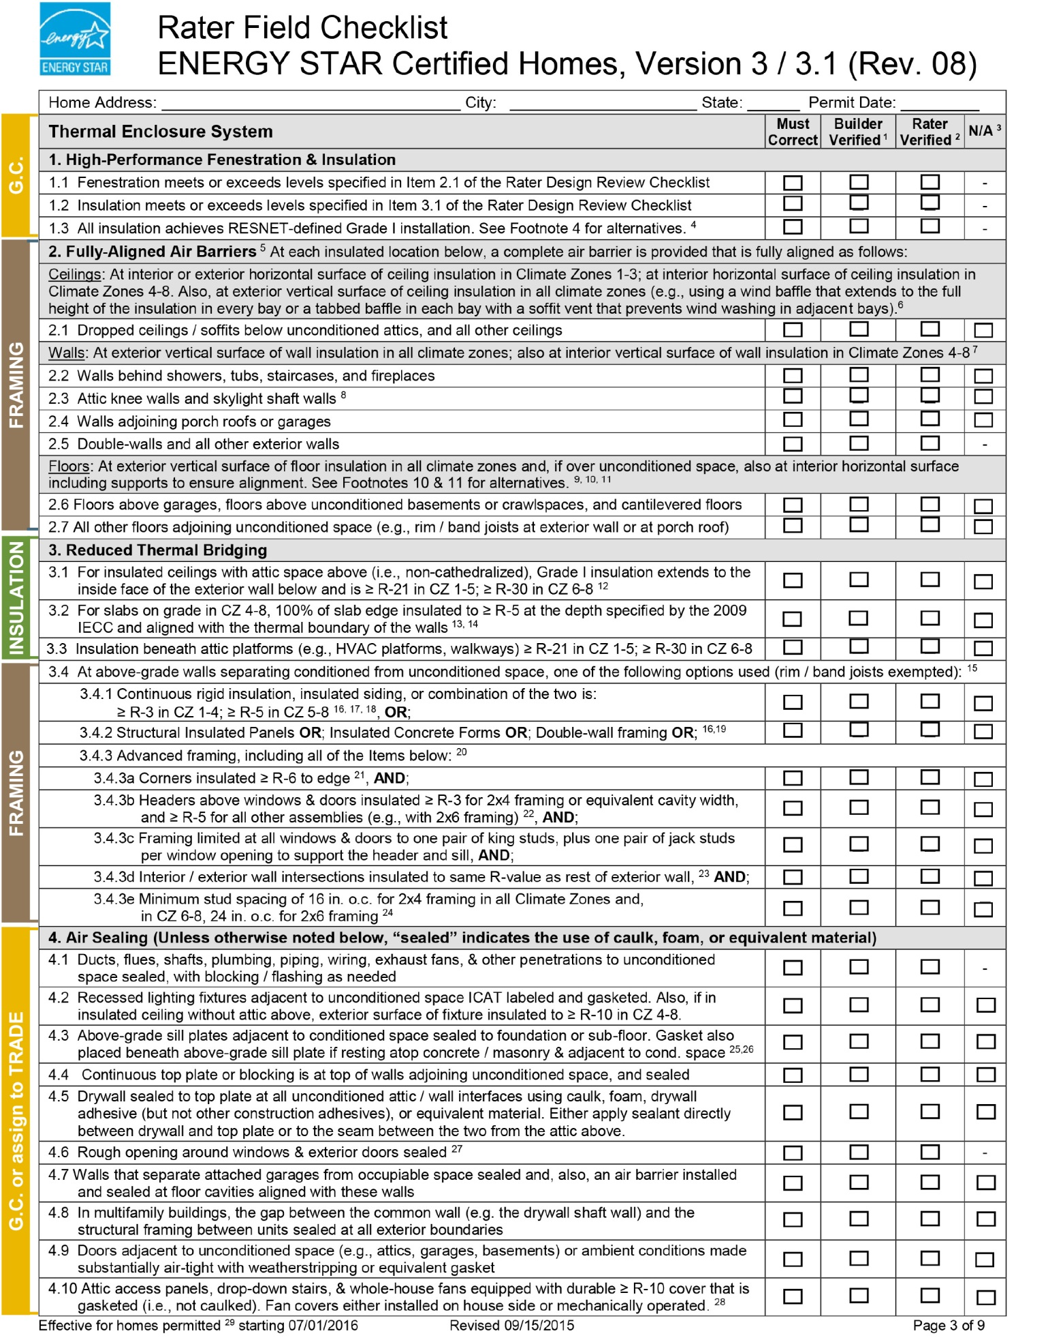

Roofing, Siding, and Weather Resistive Barrier

read this before bidding
You are bidding on a project that is pursuing Enterprise Green Communities Certification. This certification is awarded to projects that follow design and installation parameters that use fewer natural resources, generate less waste and contain fewer toxic materials, reduces the cost of operation and maintenance, leading to a healthier environment. In addition to numerous mandatory requirements, the project must also earn a minimum number of optional points for certification.
Your quality of work is critical to the success of this job. This Scope of Work outlines contractual requirements that directly support the selected certification requirements (Enterprise criterion) that your trades will be held accountable for if selected. Please read through this document carefully to know what is expected of your trade with regard to products, submittals, execution, quality control and coordination with other trades.

coordination, communication and quality assurance Across Trades
This Scope of Work addresses responsibilities that are often sequenced across multiple trades in order to achieve the Enterprise requirements. Experience shows that successful end results take a coordinated effort across trades and with the General Contractor, and that when trades acknowledge how their work intersects, influences and can impact the work of trades outside of their own scope, projects pass more inspections the first time, errors and failures are reduced or eliminated, and project schedules and budgets are met.
With specific regard to the issue of air sealing and maintaining thermal barriers, the trades grouped in this Scope of Work may need a higher degree of communication and attention to details that may impact the quality of their work or that of trades sequenced prior to or after their work. Examples of best practices include:

Participation at a preconstruction coordination meeting;

Trade foremen that build and maintain crew awareness of trade sequencing on a specific project;

Processes for tracking and communicating to the General Contractor or other trades issues that need timely attention from other trades to ensure quality and reduce rework expenses later in the project.

Submittals, Products, and Execution
You will be expected to provide the General Contractor with product data in accordance with contract requirements. Since trades must contribute to certification, careful attention needs to be paid to product requirements related to your trade. Table 1 shows the submittal, product, and execution requirements specific to the Enterprise Green Communities Criteria. Your work will be verified on site by a third-party verifier. You will be contracted to provide the quality of work necessary to earn certification, which may vary from typical construction practices, but are in line with widely-recognized best practices.

Read through the Attachments
Enterprise Green Communities Criteria requires ENERGY STAR Homes Certification of new construction single-family projects. This involves the design, documentation, installation, and verification of items in compliance with the ENERGY STAR Certified Homes requirements in force at the time building permits are pulled. The most current ENERGY STAR Homes Water Management System checklist Version 3 is attached and annotated to reflect requirements related to concrete installation, for your convenience.

Table 4. Enterprise Green Communities Criteria and associated submittal, product, and execution requirements related to roofing, siding, and weather resistive barrier
Material and Associated Enterprise Green Communities Criteria | Submittal Requirements | Product Requirements | Execution Requirements
All  5.1a Building Performance Standard | Documentation related to all related items on the ENERGY STAR Water Management System Builder Requirements Version 3/3.1 (Rev.08) | In all 2009 IECC Climate Zones, use self-adhering polymer-modified bituminous membrane at all valleys & roof deck penetrations  In 2009 IECC Climate Zones 5 & higher, also use self-adhering polymer-modified bituminous membrane over sheathing at eaves from the edge of the roof line to > 2 ft. up roof deck from the interior plane of the exterior wall | Meet all installation requirements called out in the ENERGY STAR Water Management System Builder Requirements
All Interior adhesives sealants  6.2 Low/No VOC Adhesives and Sealants | VOC level in g/L for multipurpose construction adhesives and single-ply roof membrane adhesives | For any adhesives and sealants (including caulk) used beneath (interior side of) the weather resistive barrier, use only products with VOC levels that comply with the respective VOC limits shown in 018113 Part 2 Products. D. Materials under Criterion 6.2
siding, roofing sheathing  6.3 Recycled Content Material | Product information that confirms post-consumer and post-industrial recycled content for [siding], [roofing], [sheathing] | At least 25% post-consumer recycled content or 50% post-industrial for [siding], [roofing], [sheathing]
siding, roofing  6.4 Regional Materials | Product information that confirms exact location where the [siding] [roofing] materials were extracted, processed, and manufactured. | Use [siding] [roofing] products that were extracted, processed, and manufactured within 500 miles of the project for a minimum of 50%, based on cost, of the respective building material’s value
roofing  6.11 Reduced Heat-Island Effect: Roofing | Product documentation demonstrating ENERGY STAR-certified roofing product | Use an ENERGY STAR-certified product for 100% of the non-vegetated roof area
WALL SYSTEMS  7.6 Water Drainage | Product information for WRB product and all associated sealants or components | [Provide a continuous housewrap/WRB] OR[install a fluid-applied WRB] | [If using a housewrap/WRB, lap shingle-style to prevent bulk water that penetrates the finished exterior cladding system from entering the wall assembly]  [If using a fluid-applied WRB, install according to manufacturer’s instructions]  Provide a pathway for bulk water that may be behind exterior cladding system to safely exit the exterior wall assembly (such as drainage plane and weep holes)
ROOF SYSTEMS  7.6 Water Drainage | Product information for all flashing, sealants, and materials used for drip edges | Install drip edge at entire perimeter of roof | At wall/roof intersections, maintain ≥ 2” clearance between wall cladding and roofing materials, install flashing along the intersection, and use kick-out flashing. See ENERGY STAR Homes Air Sealing Critical Details Tech Tips for additional guidance.
SIDING, ROOFING  8.3 Resident Manual | Specific maintenance instructions for any products, including frequency of maintenance inspections or tasks and approved products to use for cleaning or maintenance

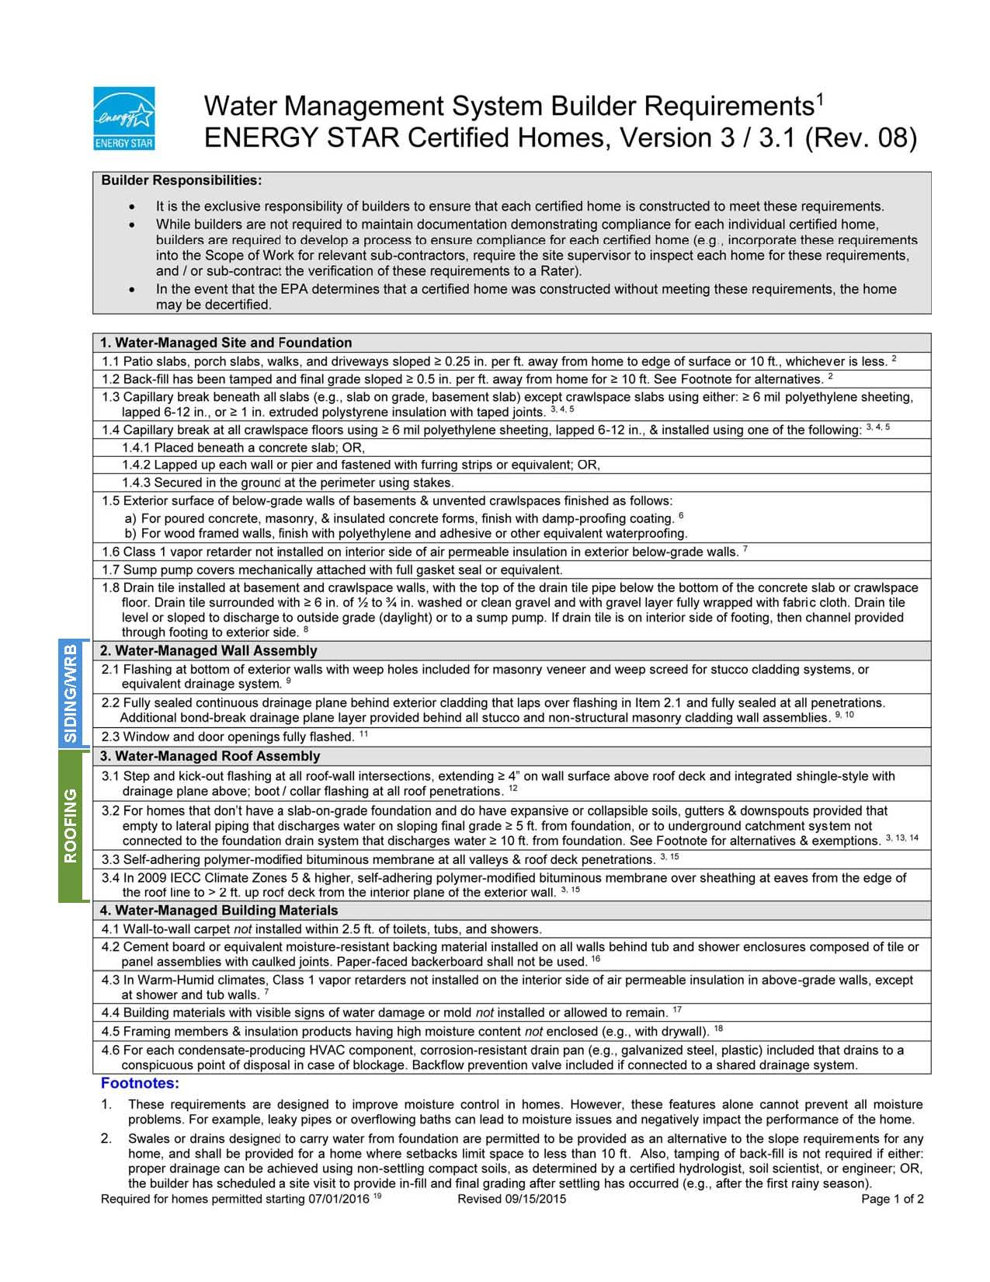

Heating, Ventilation and Air Conditioning

read this before bidding
You are bidding on a project that is pursuing Enterprise Green Communities Certification. This certification is awarded to projects that follow design and installation parameters that use fewer natural resources, generate less waste and contain fewer toxic materials, reduces the cost of operation and maintenance, leading to a healthier environment. In addition to numerous mandatory requirements, the project must also earn a minimum number of optional points for certification.
Your quality of work is critical to the success of this job. This Scope of Work outlines contractual requirements that directly support the selected certification requirements (Enterprise criterion) that your trades will be held accountable for if selected. Please read through this document carefully to know what is expected of your trade with regard to products, submittals, execution, quality control and coordination with other trades.

coordination, communication and quality assurance Across Trades
This Scope of Work addresses responsibilities that are often sequenced across multiple trades in order to achieve the Enterprise requirements. Experience shows that successful end results take a coordinated effort across trades and with the General Contractor, and that when trades acknowledge how their work intersects, influences and can impact the work of trades outside of their own scope, projects pass more inspections the first time, errors and failures are reduced or eliminated, and project schedules and budgets are met.
With specific regard to the issue of air sealing and maintaining thermal barriers, the trades grouped in this Scope of Work may need a higher degree of communication and attention to details that may impact the quality of their work or that of trades sequenced prior to or after their work. Examples of best practices include:

Participation at a preconstruction coordination meeting;

Trade foremen that build and maintain crew awareness of trade sequencing on a specific project;

Processes for tracking and communicating to the General Contractor or other trades issues that need timely attention from other trades to ensure quality and reduce rework expenses later in the project.

Submittals, Products, and Execution
You will be expected to provide the General Contractor with product data in accordance with contract requirements. Since trades must contribute to certification, careful attention needs to be paid to product requirements related to your trade. Table 1 shows the submittal, product, and execution requirements specific to the Enterprise Green Communities Criteria. Your work will be verified on site by a third-party verifier. You will be contracted to provide the quality of work necessary to earn certification, which may vary from typical construction practices, but are in line with widely-recognized best practices.

Read through the Attachments
Enterprise Green Communities Criteria requires ENERGY STAR Homes Certification of new construction single-family projects. This involves the design, documentation, installation, and verification of items in compliance with the ENERGY STAR Certified Homes requirements in force at the time building permits are pulled. The most current ENERGY STAR Homes HVAC Design Report and HVAC Commissioning Checklist Version 3 is attached and annotated to reflect requirements related to concrete installation, for your convenience.
To be eligible to install HVAC equipment in homes being certified under ENERGY STAR Version 3, HVAC contractors must be credentialed through and EPA-recognized HVAC Quality Installation and Training Organization (H-QUITO). HVAC contractors must submit documentation of their credential with their bids. For more information visit: https://www.energystar.gov/index.cfm?c=bldrs_lenders_raters.nh_hvac_contractors.

Table 5. Enterprise Green Communities Criteria and associated submittal, product, and execution requirements related to HVAC
Material and Associated Enterprise Green Communities Criteria | Submittal Requirements | Product Requirements | Execution Requirements
All  5.1a Building Performance Standard: New Construction  Or  5.1c Building Performance Standard: Moderate and Substantial Rehab  and  5.2a Additional Reduction in Energy Use | Documentation of HVAC contractor’s current credentials from a recognized HVAC Quality Installation and Train Organization (H-QUITO)  Documentation showing HVAC equipment is correctly sized and ENERGY STAR compliant | HVAC equipment must be ENERGY STAR compliant and sized to meet the design flow rates in the installed condition | Per Mandatory requirements of 5.1a, your work will be verified by a 3rd-party ENERGY STAR Rater. Familiarize yourself with all related ENERGY STAR requirements. The annotated details in the attached HVAC Design Report and HVAC Commissioning Checklist are additional to the details below  Per Mandatory requirements in 5.1c, your work will be verified by a 3rd-party HERS Rater.  For best practice, ensure work is consistent with HVAC design requirements; reference applicable ENERGY STAR requirements in the attached Rater Checklist where required
All Interior adhesives sealants  6.1 Low/No VOC Paints, Coatings, and Primers  6.2 Low/No VOC Adhesives and Sealants | VOC level in g/L | For all interior paints, coatings, primers, adhesives, and sealants, use only products with VOC levels that comply with the respective VOC limits shown in 018113 Part 2 Products. D. Materials under Criteria 6.1 and 6.2
cardboard, metal  6.12 Construction Waste Management | Submit all project-specific individual recycle and/or waste management tickets for respective materials |  | Recycle [all cardboard], [all metals]
Venting  7.1 Ventilation | Submit Product data for in-unit ventilation system(s) in compliance with ASHRAE 62.2-2010 requirements for:  1) local mechanical exhaust system in bathrooms;  2) local mechanical exhaust system in kitchens; and  3) whole-house mechanical ventilation  Submit product data for any individual bathroom fans demonstrating ENERGY STAR label and humidistat sensor, timer or other control  Submit product data for any central rooftop fans showing direct-drive and variable-speed capability  Submit product data for any fan serving multiple units with design CFM 300-2000 showing ECM motors | In-unit ventilation system(s) shall comply with ASHRAE 62.2-2010 requirements for local mechanical exhaust system in bathrooms and kitchens, and whole-house mechanical ventilation  Individual bathroom fans shall be  1) ENERGY STAR labeled;  2) turn on with the light switch; and  3) equipped with a humidistat sensor, timer or other control  Any central rooftop fans shall be direct-drive and variable-speed  Any fan serving multiple units with design CFM 300-2000 shall be equipped with an ECM motor | All ventilation systems and ductwork must be installed per manufacturer’s recommendations. This includes following guidelines for minimum straight duct length from fan boxes prior to first bend, type of duct, number of bends to exterior wall termination, and duct sizing. See ENERGY STAR Homes Ductwork Critical Details Tech Tips for additional guidance.
Venting  7.2 Clothes Dryer Exhaust |  |  | Clothes dryers must be exhausted directly to the outdoors using rigid-type ductwork, except for condensing dryers or heat pump dryers, which must be plumbed to a drain
Mechanical  7.3 Combustion Equipment | Submit product data for any combustion water heating or space heating equipment showing compliant venting | Any combustion water heating or space heating equipment located within the conditioned envelope shall be power-vented or direct-vented | For rehab projects with any atmospheric combustion space or water heating equipment within the conditioned envelope, conduct combustion safety testing for minimum 10% of dwelling units in accordance with RESNET or BPI Combustion Safety Test Procedures. Report any deficiencies immediately to the owner or owner’s representative
Mechanical, venting  7.9 Garage Isolation |  | Do not install ductwork or air handling equipment in a garage | Seal all pipe and conduit penetrations with material compatible with the adjacent materials, compliant with VOC levels as indicated in Criteria 6.1, and resilient to temperature fluctuations and providing fire-resistive characteristics if required by authorities having jurisdictions
Mechanical, venting  8.3 Resident Manual | Specific maintenance instructions for any equipment or controls, including frequency of maintenance inspections or tasks and approved products to use for maintenance tasks

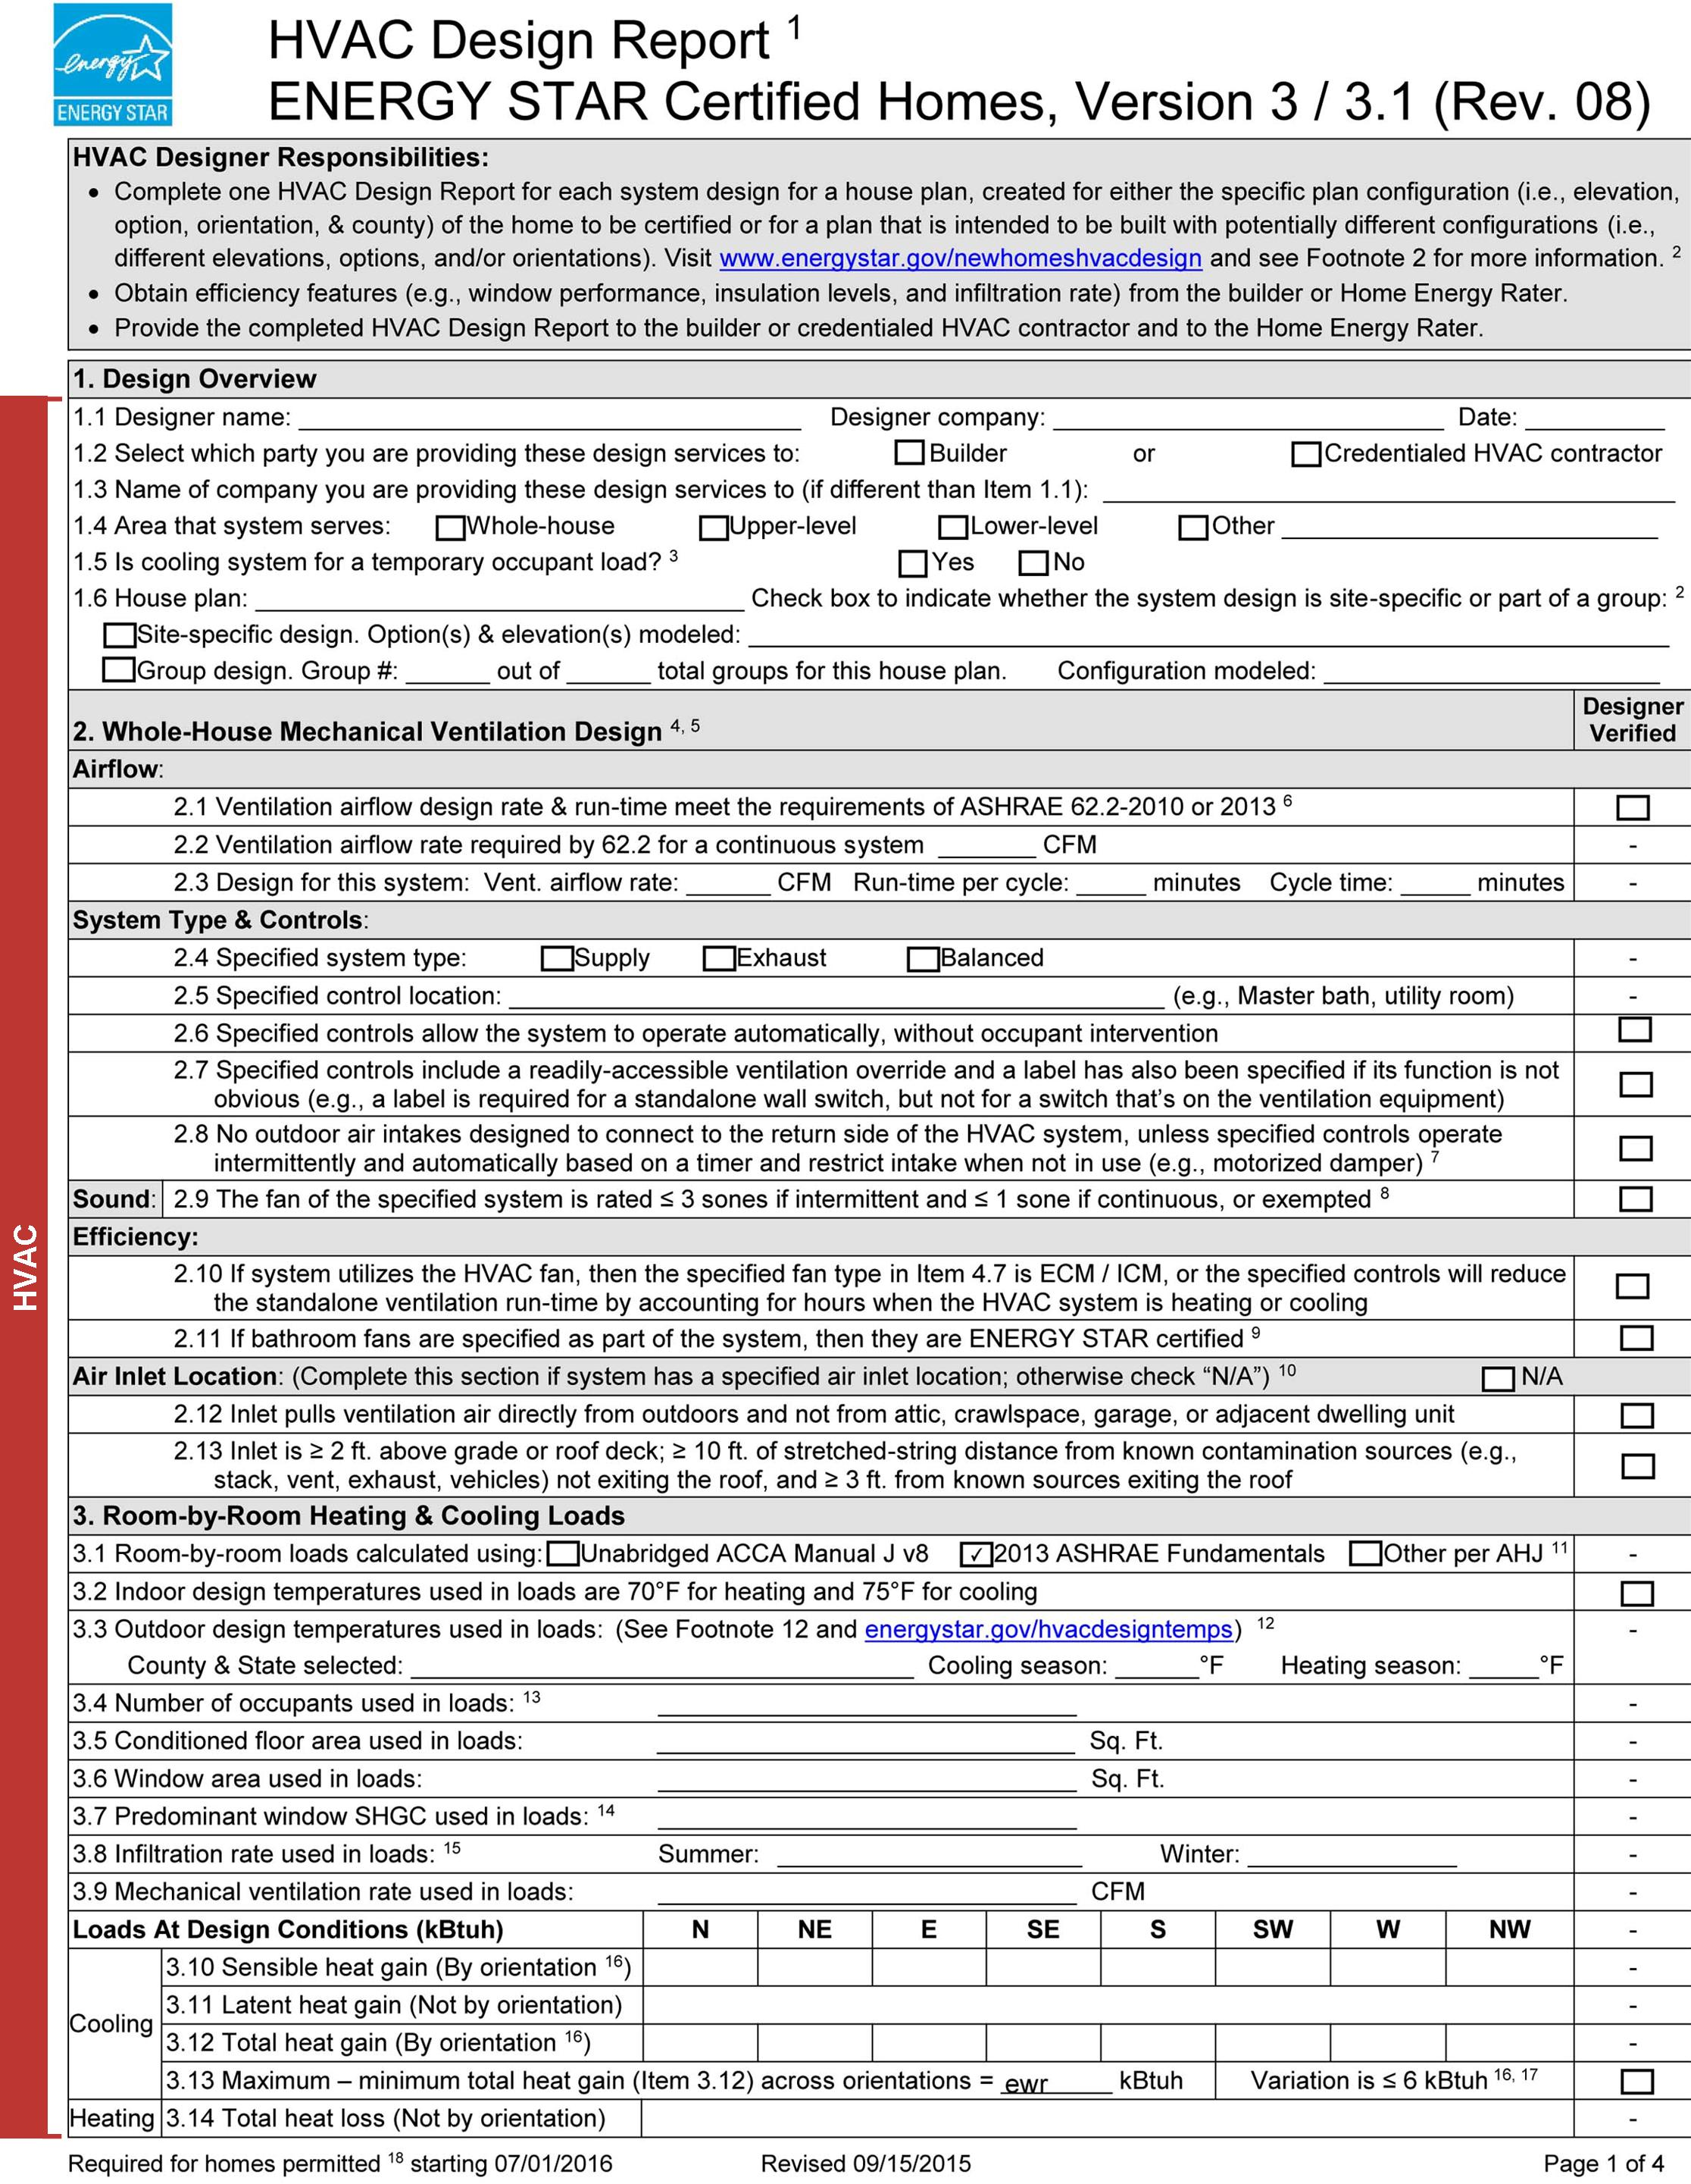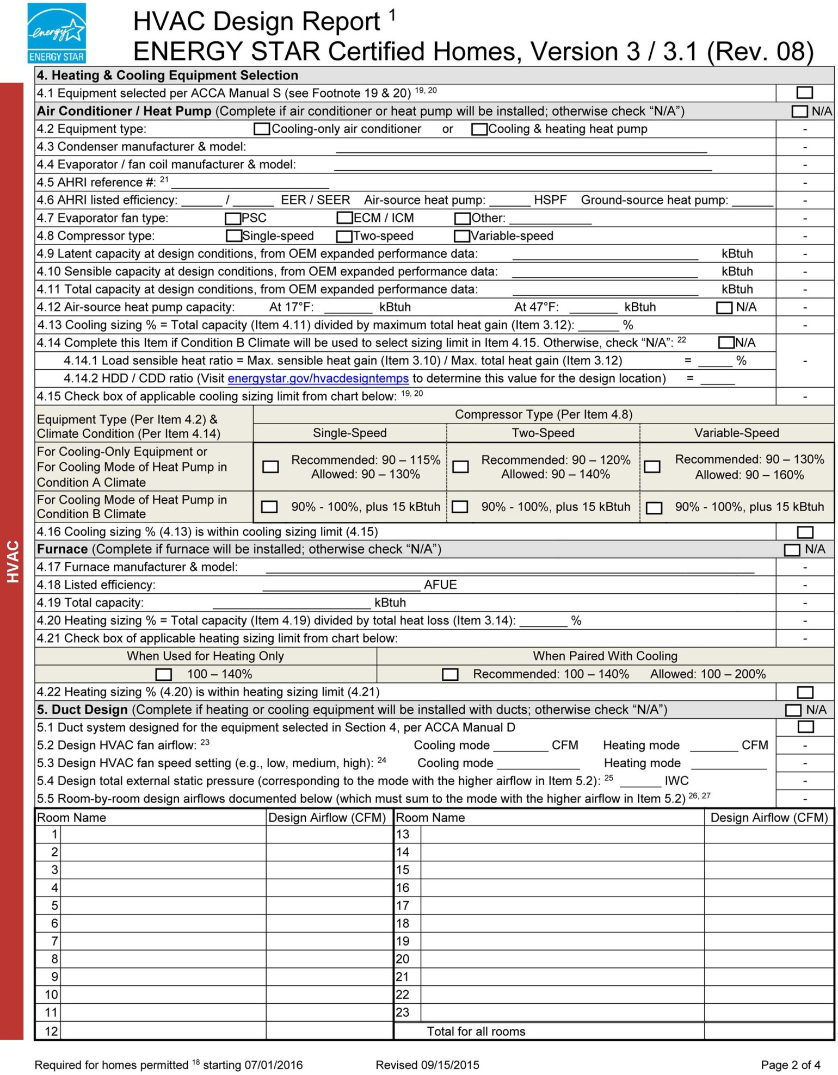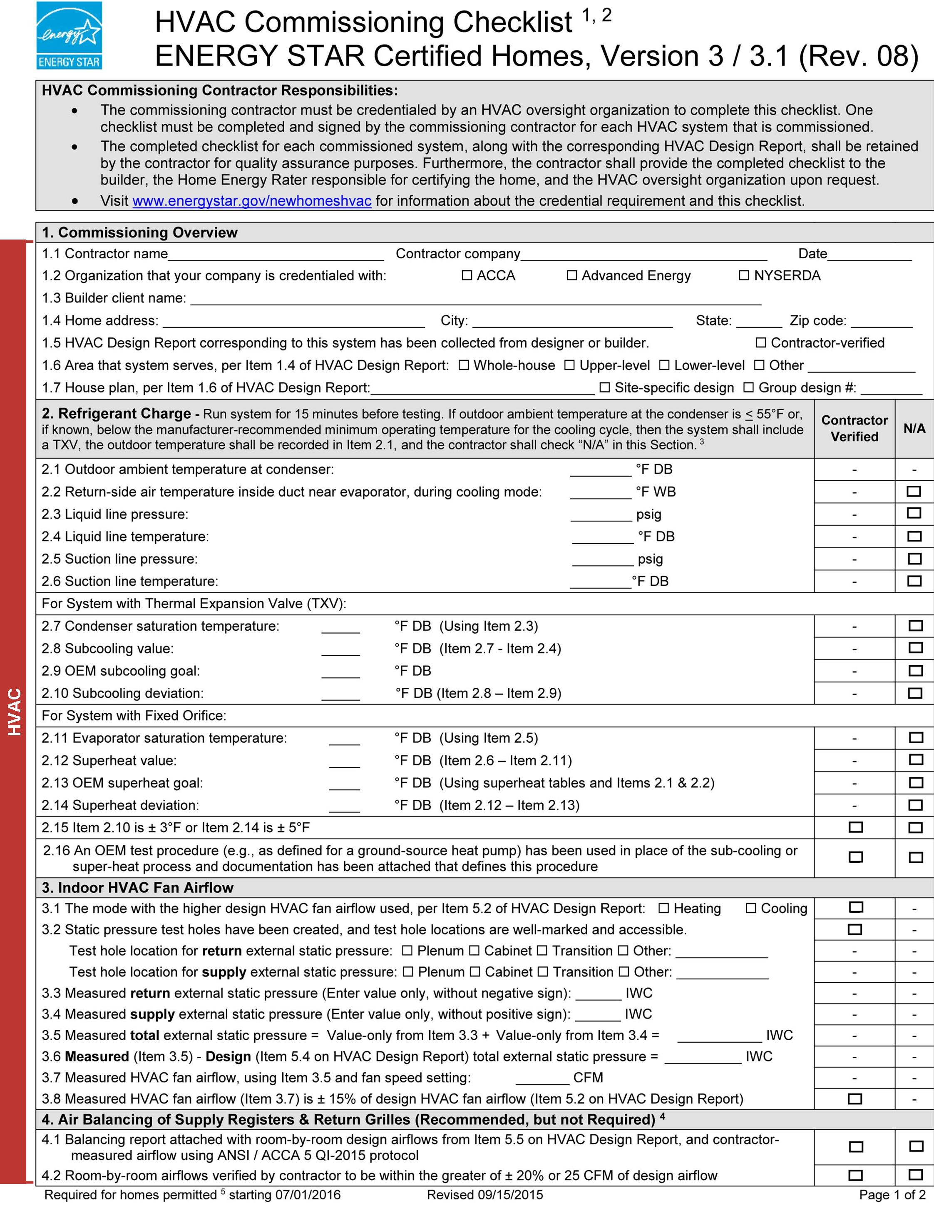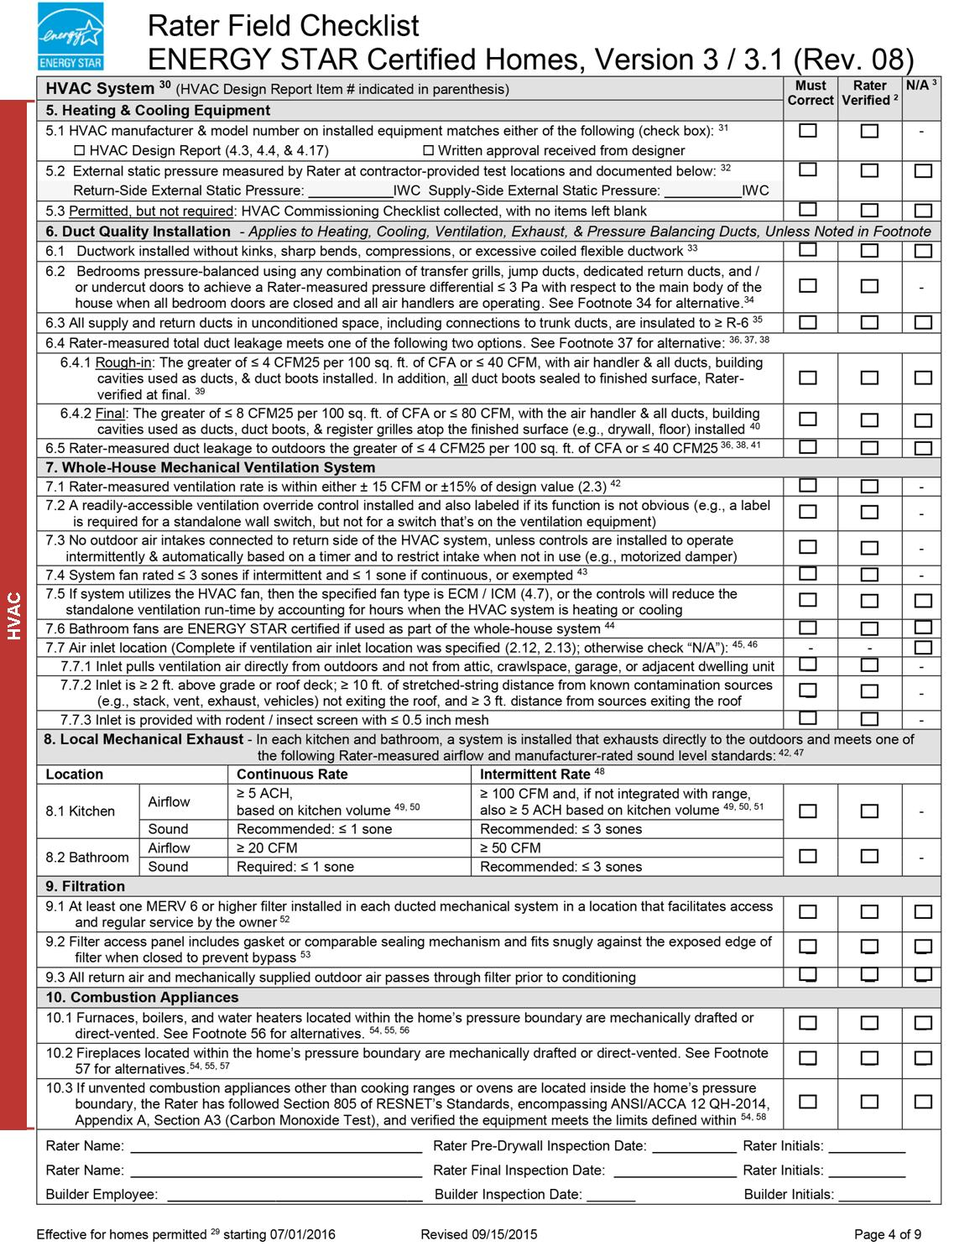

Electrical

read this before bidding
You are bidding on a project that is pursuing Enterprise Green Communities Certification. This certification is awarded to projects that follow design and installation parameters that use fewer natural resources, generate less waste and contain fewer toxic materials, reduces the cost of operation and maintenance, leading to a healthier environment. In addition to numerous mandatory requirements, the project must also earn a minimum number of optional points for certification.
Your quality of work is critical to the success of this job. This Scope of Work outlines contractual requirements that directly support the selected certification requirements (Enterprise criterion) that your trades will be held accountable for if selected. Please read through this document carefully to know what is expected of your trade with regard to products, submittals, execution, quality control and coordination with other trades.

coordination, communication and quality assurance Across Trades
Experience shows that successful end results take a coordinated effort across trades and with the General Contractor, and that when trades acknowledge how their work intersects, influences and can impact the work of trades outside of their own scope, projects pass more inspections the first time, errors and failures are reduced or eliminated, and project schedules and budgets are met.
Examples of best communication and cross-trade coordination practices include:

Participation at a preconstruction coordination meeting;

Trade foremen that build and maintain crew awareness of trade sequencing on a specific project;

Processes for tracking and communicating to the General Contractor or other trades issues that need timely attention from other trades to ensure quality and reduce rework expenses later in the project.

Submittals, Products, and Execution
You will be expected to provide the General Contractor with product data in accordance with contract requirements. Since trades must contribute to certification, careful attention needs to be paid to product requirements related to your trade. Table 1 shows the submittal, product, and execution requirements specific to the Enterprise Green Communities Criteria. Your work will be verified on site by a third-party verifier. You will be contracted to provide the quality of work necessary to earn certification, which may vary from typical construction practices, but are in line with widely-recognized best practices.

Read through the Attachments
Enterprise Green Communities Criteria requires ENERGY STAR Homes Certification of new construction single-family projects. This involves the design, documentation, installation, and verification of items in compliance with the ENERGY STAR Certified Homes requirements in force at the time building permits are pulled. The most current ENERGY STAR Homes HVAC Design Report Version 3 is attached and annotated to reflect requirements related to concrete installation, for your convenience.

Table 6. Enterprise Green Communities Criteria and associated submittal, product, and execution requirements related to Electrical
Material and Associated Enterprise Green Communities Criteria | Submittal Requirements | Product Requirements | Execution Requirements
All  5.1a Building Performance Standard: New Construction  Or  5.1c Building Performance Standard: Moderate or Substantial Rehab  and  5.2a Additional Reduction in Energy use | Documentation showing whole house and bathroom fans showing fan flow rate and ENERGY STAR compliance | Whole house and bathroom fans must be ENERGY STAR compliant and sized to meet the design flow rates in the installed condition | Per Mandatory requirements in 5.1a, your work will be verified by a 3rd-party ENERGY STAR Rater. Familiarize yourself with all related ENERGY STAR requirements. Some critical details are annotated in the attached HVAC Design Report and are additional to the details below  Per Mandatory requirements in 5.1c, your work will be verified by a 3rd-party HERS Rater.  For best practice, ensure work is consistent with ventilation design requirements; reference applicable ENERGY STAR requirements in the attached Rater Checklist where required
electrical  5.5 Lighting | Submit product data for all lighting fixtures, lighting and lamps documenting efficacy in lumens per watt (lm/W)  Submit product data for all lighting controls | Permanently installed lighting fixtures shall have efficacy ≥ 40 lumens per watt.  1) Recessed lights are ballasted compact fluorescent fixtures or use ENERGY STAR qualified LED lamps; and  Fixtures are Insulation Contact Air-Tight rated.  2) Common area lighting are ballasted compact fluorescent fixtures or use ENERGY STAR qualified LED bulbs; and are controlled by occupancy sensors or automatic bi-level controls  3) Exterior lamps are fluorescent or LED; and are: ENERGY STAR certified when available in the product category; Dark-Sky approved; Have motion sensor controls, integrative photo cells, photo sensors or astronomic time-clock operation.  Exit signs shall consume ≤ 5 watts and have battery backup when located above stairwell doors and other forms of egress.
electrical  5.6 Electricity Meter | Submit product data for individual dwelling unit electric meter/submeter | Electric meter or submeter shall be installed that is capable of individually metering each dwelling unit’s electricity.
electrical  5.7a Photovoltaic (/Solar Hot Water Ready) | Submit construction documents showing future location, size and orientation of solar collectors, and percentage of gross roof area it covers.  Submit construction documents showing location of wiring and/or plumbing to connect solar collectors with inverter and/or hot water storage system. [System with roof mounted collectors include documentation estimating remaining useful life of roof]
electrical  5.7b Renewable Energy | Submit product data documenting number of solar panels, orientation, tilt angle of array, individual panel’s peak power rating in Watts and inverter efficiency | Provide photovoltaic system for [20, 30 40] percent of energy demand as calculated by energy model
electrical  5.8a Resilient Energy Systems: Floodproofing |  |  | Locate the service disconnect at a readily accessible location above the design flood elevation
electrical  5.8b Resilient Energy Systems: Islandable Power | Submit [Option 1: product data documenting number of solar panels, orientation, tilt angle of array, and individual panel’s peak power rating in Watts; inverter efficiency and emergency switching controls] or [Option 2: product data documenting number of solar panels, orientation, tilt angle of array, individual panel’s peak power rating in Watts; inverter efficiency, battery storage capacity and automatic transfer switch] or [Option 3: product data documenting generator power rating and automatic transfer switch] | Install [Option 1: Photovoltaic system with inverter capable of providing limited access to solar-generated power when grid power is down and PV system is generating.] or [Option 2: Photovoltaic system with battery storage capable of providing stored power to critical circuits when grid power is down.] or [Option 3: Permanent generator capable of providing power to critical circuits when grid power is down.]
All Interior adhesives sealants  6.1 Low/No VOC Paints, Coatings, and Primers  6.2 Low/No VOC Adhesives and Sealants | VOC level in g/L | For all interior paints, coatings, primers, adhesives, and sealants, use only products with VOC levels that comply with the respective VOC limits shown in 018113 Part 2 Products. D. Materials under Criteria 6.1 and 6.2
cardboard, metal  6.12 Construction Waste Management | Submit all project-specific individual recycle and/or waste management tickets for respective materials |  | Recycle [all cardboard], [all metals]
Carbon monoxide alarms  7.9 Garage Isolation | Submit product data for hard-wired carbon monoxide alarm with battery backup | Install one hard-wired carbon monoxide (CO) alarm with battery backup function for each sleeping zone of the project | CO alarms must be placed per National Fire Protection Association (NFPA) 720
Electrical / Lighting  8.3 Resident Manual | Specific maintenance instructions for any equipment or controls, including frequency of maintenance inspections or tasks and approved products to use for maintenance tasks  Include warranty information for all lighting fixtures and lamps (bulbs), as-built lighting plans and detailed accompanying lighting fixture schedule to make fixture and lamp (bulb) replacement straight forward

Plumbing

read this before bidding
You are bidding on a project that is pursuing Enterprise Green Communities Certification. This certification is awarded to projects that follow design and installation parameters that use fewer natural resources, generate less waste and contain fewer toxic materials, reduces the cost of operation and maintenance, leading to a healthier environment. In addition to numerous mandatory requirements, the project must also earn a minimum number of optional points for certification.
Your quality of work is critical to the success of this job. This Scope of Work outlines contractual requirements that directly support the selected certification requirements (Enterprise criterion) that your trades will be held accountable for if selected. Please read through this document carefully to know what is expected of your trade with regard to products, submittals, execution, quality control and coordination with other trades.

coordination, communication and quality assurance Across Trades
Experience shows that successful end results take a coordinated effort across trades and with the General Contractor, and that when trades acknowledge how their work intersects, influences and can impact the work of trades outside of their own scope, projects pass more inspections the first time, errors and failures are reduced or eliminated, and project schedules and budgets are met.
Examples of best communication and cross-trade coordination practices include:

Participation at a preconstruction coordination meeting;

Trade foremen that build and maintain crew awareness of trade sequencing on a specific project;

Processes for tracking and communicating to the General Contractor or other trades issues that need timely attention from other trades to ensure quality and reduce rework expenses later in the project.

Submittals, Products, and Execution
You will be expected to provide the General Contractor with product data in accordance with contract requirements. Since trades must contribute to certification, careful attention needs to be paid to product requirements related to your trade. Table 1 shows the submittal, product, and execution requirements specific to the Enterprise Green Communities Criteria. Your work will be verified on site by a third-party verifier. You will be contracted to provide the quality of work necessary to earn certification, which may vary from typical construction practices, but are in line with widely-recognized best practices.

Table 7. Enterprise Green Communities Criteria and associated submittal, product, and execution requirements related to plumbing
Material and Associated Enterprise Green Communities Criteria | Submittal Requirements | Product Requirements | Execution Requirements
irrigation  3.5b Efficient Irrigation and Water Reuse | Submit product data (cut sheets, control sequence and instructions, operations and maintenance data, and warranty information) for all system components related to water reuse for irrigation including storage tank(s), plumbing valves and controls, and other associated equipment | Install irrigation that utilizes treated greywater, rainwater, or municipal recycled water for at least 50% of the site’s irrigation
plumBing fixtures  4.1Water-Conserving Fixtures | Submit product data for toilets and urinals documenting flush rate in gallons per flush (gpf); for showerheads, kitchen and lavatory faucets, documenting flow rate in gallons per minute (gpm)  Submit product data for toilets, urinals, showerheads, and lavatory faucets documenting fixture is WaterSense-labeled | Toilets must be WaterSense-labeled and ≤ 1.28 gallons per flush (gpf)  Urinals must be WaterSense-labeled and ≤ 0.5 gpf  Showerheads must be WaterSense-labeled and ≤ 2.0 gallons per minute (gpm)  Kitchen faucets must be ≤ 2.0 gpm  Lavatory faucets must be WaterSense-labeled and ≤ 1.5 gpm
pluMbing fixtures  4.2Advanced Water Conservation | Submit product data for toilets and urinals documenting flush rate in gallons per flush (gpf); for showerheads, kitchen and lavatory faucets documenting flow rate in gallons per minute (gpm).  Submit product data for toilets, urinals, showerheads, and lavatory faucets documenting fixture is WaterSense-labeled. | Toilets must be WaterSense-labeled and ≤ 1.1 gallons per flush (gpf)  Showerheads must be WaterSense-labeled and ≤ 1.5 gallons per minute (gpm)  Kitchen faucets must be WaterSense-labeled and ≤ 1.5gpm  Lavatory faucets must be WaterSense-labeled and ≤ 1.0 gpm
plumBing Piping and equipment  4.3 Leaks and Water Metering | Submit pressure-loss test results and visual inspection log documenting building has no detectable leaks AND [Option 1: product data for dwelling unit’s water meter/submeter. Option 2: product data for domestic water riser water meter/submeter] | Install meter or submeter in each dwelling unit with technology capable of tracking water use. Separately meter outdoor water consumption. | Conduct pressure-loss test in compliance with EPA WaterSense Inspection and Verification for WaterSense-labeled New Homes  Conduct visual inspection of every accessible, visible water supply connection and valve for water-using fixture, appliance and equipment  Any leak detected during inspection shall be fixed
plumBing Piping and equipment  4.4 Efficient Plumbing Layout and Design | Submit calculations of pipe runs and stored volume  Submit hot water delivery test results documenting volume of water collected from the hot water fixtures before hot water is delivered.  Submit product data for recirculation pumps and controls documenting ability to be demand-initiated. [Required if using recirculation system to meet credit] | Size and install piping that will store no more than 0.5 gallons of water in any piping/manifold between the hot water source and any hot water fixture  Install recirculation pump which is demand-initiated and NOT activated solely on a timer and/or temperature sensor  [Required if using recirculation system to meet credit] | Conduct testing of hot water fixtures in compliance with EPA WaterSense Inspection and Verification for WaterSense-labeled New Homes to verify no more than 0.6 gallons of water is collected from the hot water fixture before hot water is delivered
plumBing Piping and equipment  4.5 Water Reuse | Submit product data for holding tank(s)/cistern(s) documenting capacity in gallons  Submit product data for pumps documenting horsepower and flow rate in gallons per minute  Submit product data for water filtration/treatment equipment documenting micron rating if water is for potable uses | Product requirements will vary depending on approach used for each project
plumBing Piping and equipment  4.6 Access to Potable Water During Emergencies | Submit [Option 2: product information for potable water storage tanks, associated valves, and any regular maintenance tasks] or [Option 3: product and location information for the drilled will with clear instructions for operation during emergencies and any related maintenance tasks] | Install [Option 2: potable water storage tanks capable of providing at least 20 gallons per resident] or [Option 3: drilled will with means for pumping water when the electric grid is down]
equipment  5.1 Building Performance Standard |  |  | Per Mandatory requirements, this project must meet ENERGY STAR Requirements, including plumbing fixture efficiencies and water heating equipment efficiencies  These requirements are not repeated in this table, so be sure you are familiar with any plumbing-related requirements
Solar hot water  5.7a Solar Hot Water Ready | Submit construction documents showing future location, size and orientation of solar collectors, and percentage of gross roof area it covers  Submit construction documents showing location of plumbing to connect solar collectors with hot water storage system (System with roof mounted collectors include documentation estimating remaining useful life of roof) | Install necessary plumbing to accommodate installation of future solar hot water system on a >= 60 square feet portion of the roof that is oriented within +/- 45 degrees of true south | Provide piping from the designed or current location of the water heater to the prospective proposed solar hot water collector location  If electrical connection is needed (for pumps or associated equipment), coordinate with electrical trade to extend conduit through the roof and to a sealed junction box
electrical  5.8a Resilient Energy Systems: Floodproofing |  |  | Locate any and all central water heater equipment above the design flood elevation
All Interior adhesives sealants  6.1 Low/No VOC Paints, Coatings, and Primers  6.2 Low/No VOC Adhesives and Sealants | VOC level in g/L | For all interior paints, coatings, primers, adhesives, and sealants, use only products with VOC levels that comply with the respective VOC limits shown in 018113 Part 2 Products. D. Materials under Criteria 6.1 and 6.2
cardboard, metal  6.12 Construction Waste Management | Submit all project-specific individual recycle and/or waste management tickets for respective materials |  | Recycle [all cardboard], [all metals]
water heaters  7.3 Combustion Equipment | Submit product data for any combustion water heating or space heating equipment showing compliant venting | Any combustion water heating or space heating equipment located within the conditioned envelope shall be power-vented or direct-vented
Water heaters  7.7 Mold Prevention: Water Heaters |  | Drain pans under tank water heaters shall be sloped and corrosion-resistant (e.g., stainless steel or plastic) with drains at the low point | Condensate lines should be drained to a drainage system, and not just deposited under slab
Equipment  8.3 Resident Manual | Specific maintenance instructions for all equipment and controls, including frequency of maintenance inspections or tasks and approved products to use for maintenance

Landscaping & Irrigation

read this before bidding
You are bidding on a project that is pursuing Enterprise Green Communities Certification. This certification is awarded to projects that follow design and installation parameters that use fewer natural resources, generate less waste and contain fewer toxic materials, reduces the cost of operation and maintenance, leading to a healthier environment. In addition to numerous mandatory requirements, the project must also earn a minimum number of optional points for certification.
Your quality of work is critical to the success of this job. This Scope of Work outlines contractual requirements that directly support the selected certification requirements (Enterprise criterion) that your trades will be held accountable for if selected. Please read through this document carefully to know what is expected of your trade with regard to products, submittals, execution, quality control and coordination with other trades.

coordination, communication and quality assurance Across Trades
This Scope of Work addresses responsibilities that are often sequenced across multiple trades in order to achieve the Enterprise requirements. Experience shows that successful end results take a coordinated effort across trades and with the General Contractor, and that when trades acknowledge how their work intersects, influences and can impact the work of trades outside of their own scope, projects pass more inspections the first time, errors and failures are reduced or eliminated, and project schedules and budgets are met.
Examples of best communication and cross-trade coordination practices include:

Participation at a preconstruction coordination meeting;

Trade foremen that build and maintain crew awareness of trade sequencing on a specific project;

Processes for tracking and communicating to the General Contractor or other trades issues that need timely attention from other trades to ensure quality and reduce rework expenses later in the project.

Submittals, Products, and Execution
You will be expected to provide the General Contractor with product data in accordance with contract requirements. Since trades must contribute to certification, careful attention needs to be paid to product requirements related to your trade. Table 1 shows the submittal, product, and execution requirements specific to the Enterprise Green Communities Criteria. Your work will be verified on site by a third-party verifier. You will be contracted to provide the quality of work necessary to earn certification, which may vary from typical construction practices, but are in line with widely-recognized best practices.

Table 8. Enterprise Green Communities Criteria and associated submittal, product, and execution requirements related to landscaping and irrigation
Material and Associated Enterprise Green Communities Criteria | Submittal Requirements | Product Requirements | Execution Requirements
plantings  3.4 Landscaping | Submit product data for plantings indicating only native or adaptive species | All trees, shrubs, groundcover, grasses, and plantings must be native or adapted to the region  All new plants must be appropriate to the site’s soil and microclimate, and none should be invasive species | Any disturbed area must be reseeded or xeriscaped with plants that meet product requirements
irrigation  3.5a Efficient Irrigation and Water Reuse | Submit product data (including cut sheets, control sequence and instructions, operations and maintenance data, and warranty information) related to:  1) Drip irrigation system for landscape planting beds  2) Timer/controller that activates valves for each watering zone  3) Moisture sensor controller or rain delay controller  4) As-built landscape plan that indicates the separate zones for turf, bedding areas, and trees based on watering needs and final installation of irrigation equipment. | Timer/Controller must be capable of activating a valve for each watering zone at the best time of day to minimize evaporative losses while maintaining healthy plants and obeying local regulations and water-use guidelines
irrigation  3.5b Efficient Irrigation and Water Reuse | Submit [Option 1: product data indicating WaterSense-labeled weather-based irrigation controller (WBIC)] or [ Option 2: product data (cut sheets, control sequence and instructions, operations and maintenance data, and warranty information) for all system components related to water reuse for irrigation including storage tank(s), plumbing valves and controls, and other associated equipment.] | Install [WaterSense-labeled weather-based irrigation controller (WBIC)] or [irrigation that utilizes treated greywater, rainwater, or municipal recycled water for at least 50% of the site’s irrigation]
Plantings  8.3 Resident Manual | Specific maintenance instructions for any plantings, including frequency of maintenance or tasks, if irrigation is permanent or just for establishment, and when/how often pruning, composting, and mulching should take place
Equipment and controls  8.3 Resident Manual | Specific maintenance instructions for any equipment or controls, including frequency of maintenance inspections or tasks and approved maintenance products to use

